**AVALON POLICE DEPARTMENT**



“With Honor We Serve”

2022 Annual Report

Prepared by:

Jeffrey R. Christopher

Chief of Police

**Chiefs’ message**

To: Mayor Martin L. Pagliughi, Council President Sam Wierman, Council Vice-President James McDermott, Councilman John McCorristin, Councilwoman Barbara Juzaitis, Councilwoman Maura Coskey, Business Administrator Scott Wahl, and Assistant B.A. James Waldron.

I am proud to provide you the Avalon Police Department Annual Report for 2022. This report is prepared to provide you an in-depth, comprehensive account your police department by the officers and civilian staff, including administration, patrol, detectives and records. I will summarize changes that occurred within the year that will reflect the commitment to service, community outreach, and dedication to duty of the men and women of this department.

Jeffrey R. Christopher

Chief of Police

**TABLE OF CONTENTS**

ORGANIZATIONS STRUCTURE ………………………………….. 4

MISSION STATEMENT ………………………………….. 5

PERSONNEL ………………………………… 6 & 7

ADMINISTRATION …………………………………… 8

PATROL …………………………………… 9

CALLS FOR SERVICE …………………………………. 9-12

BICYCLE VIOLATIONS …………………………………… 13

DETECTIVES …………………………………... 14 - 17

SUPPORT STAFF …………………………………… 17

SPECIAL OFFICERS …………………………………… 18

MARINE UNIT …………………………………… 19

COMAND AND LEADERSHIP ……………………………….…. 20

JUVENILE JUSTICE ………………………………….. 21

ACCREDITATION ………………………………….. 22 & 23

TRAINING …………………………………… 24

INSTRUCTORS ………………………………….. 25

L.E.A.D …………………………………… 26

COMMUNITY OUTREACH …………………………………… 27-32

RETIRED OFFICERS ……………………………….….. 33

HIRED NEW OFFICERS ………………………………….. 33-34

PROMOTIONS …………………………………… 35

RECOGNITION AND AWARDS ………………………………….. 36-37

GOALS AND OBJECTIVES ………………………………….. 38

CONCLUSION ------------------------------ 39

ORGANIZATIONAL STRUCTURE

**Mission Statement**

The mission of the **Avalon Police Department** is to protect and serve the citizens of Avalon with the utmost professionalism to create a safe environment to live and vacation, by providing equitable enforcement of laws, diligent patrols, thorough investigations and outstanding community relationships”

Revised 2018 Chief Christopher

**PERSONNEL**

The Avalon Police Department is comprised of twenty-one (21) sworn law enforcement officers and three (3) administrative support staff personnel. The number of special officers fluctuates yearly.

Jeffrey R. Christopher

***Chief of Police***

Sean McNair

***Captain of Police***

***Sergeants:***

Eric Heisman Administration

Matt Sykes Patrol

William Robinson Patrol

Steve Bowers Patrol

Greg Armstrong Detective Bureau

Matt Ardelean Patrol

***Patrolman: Detective:***

Tu-Juan Baile James P. Savini

Robert Hampf

Mark Glassford

Nick Brady

Anthony DeCesero

Andrew Peahota

Lukas Hill

Daniel Featherer

Joseph Stoltenberg

Quar’tus Byrd

Owen Pricket

Kyle Roscoe

**Records Administrator Assist. Records Administrator Administrative Assistant**

Dawn Brady Debbie Foley Alexis Hagner

**SPECIAL OFFICERS**

**Special Class 1 Police Officers**

Alexis Hagner also, administrative assistant

Ed Szubski marine unit

Robert Armstrong marine unit

Colby Walk

Sarah Frazier

Amy Escalante Resigned mid-summer

Alec Elia Resigned mid-summer

**Special Class 2 Police Officers**

Cullen Rutter resigned mid-summer

Frank Defeo resigned mid-summer

Jack Washington resigned mid-summer

Brendan Egan resigned mid-summer

Brandon McKeirnan

**ADMINISTRATION**

**Chief Jeff Christopher** is the head of the Avalon Police Department and responsible for the day to day operations and to administer and enforce rules and regulations of the department for its efficiency. Chief Christopher has nearly twenty-three years of experience as a full-time police officer and three additional years prior as a special class 2 officer. The chief assigns the duties of personnel and manages the department including purchasing within budgeted resources. The chief sets policy and procedures, issues directives and orders, attendance at borough council meetings, meets with community organizations, and delegate’s authority as appropriate for the efficient operation of the department. The chief of police shall exercise any and all rights, authorities, powers, and responsibilities reserved solely as set forth in NJSA 40A:14-118 and reports to Avalon Borough Council once per month.

**Captain Sean McNair** commands the operations and administrative divisions of the police department and reports directly to the chief. Captain McNair has 14 years of experience as a full-time officer and three years prior as a special class 2 officer. Duties include: supervision of the administrative and operations divisions, has charge of the department in the chief’s absence, Internal Affairs supervisor, department payroll, department training, approves time off, assigns officers engaged in activities to protect persons and property within the borough, reviews reports, reviews daily logs, evaluates sergeants, interviews and hires special officers, and performs any duties as needed by the chief.

**Sergeant Eric Heisman** is the administrative sergeant and reports to the captain. Sgt. Heisman has 17 years of experience. Primary responsibilities include, but are not limited to: maintaining department accreditation, grants and purchasing, community events, safety, supervision of special officers, vehicle fleet management, supervision of the records bureau, and body worn camera reviews. In addition, oversees the smooth operation and maintenance of the police building, computer systems, technology, and assists with training.

**PATROL**

The **Patrol Division** is the most visible part and usually the public’s first point of contact. Patrolmen work twelve hour shifts, rotating from day to night shift every two weeks. Shifts begin at either 6 am or 6 pm.

There are four patrol squads. Each squad has four officers, a patrol sergeant and three patrolmen. Patrol officers are always in full dress uniform. There is a minimum of one patrol car required on the road at all times, barring an emergency situation or operational necessity. Primary duties of the patrolmen include: vehicle patrol, criminal law enforcement, traffic enforcement, borough ordinance enforcement, preliminary investigations, accepting reports and complaints, responding to various calls for service, security at accident/fire scenes, responding to medical related emergencies, and protection of all persons and property within the borough. Below is a list of generated reports and calls for service that reflect the calls for service of the patrolman for the year 2022.

**CALLS FOR SERVICE**

There were 3,171 calls for service. That number reflects any call that was received from a citizen. There were 20,290 incidents. This number is reflected anytime an incident is created in our system. An incident can be anything an officer does in the course of their duties such as a call from citizen as well as self-initiated activity.

**Incidents: Enforcement 2019 2020 2021 2022**

Motor Vehicle Stops 3211 804 1632 1930

Motor Vehicle Crash 76 59 84 89

Traffic Summons 524 153 360 417

Traffic Warnings 2620 736 1366 1522

Warrant Arrest 49 15 11 8

Parking Summons 676 409 717 798

Boat Violations Summons 25 3 14 6

Boat Violations Warning 70 19 35 110

Boat Assist 18 13 32 49

Borough Ordinance Summons 276 130 296 139

**2019 2020 2021 2022**

Noise Unfounded 146 243 97 90

Trash Summons Issued 47 13 14 9

Unlicensed driver 24 7 20 25

Investigations 102 72 131 75

Driving While Intoxicated 13 12 21 12

Suspended Driver 31 8 8 20

Bicycle Violations – stops 1838 1197 1828 1137

Criminal Mischief 32 37 46 17

Missing Person 17 16 24 27

Simple Assault 17 4 14 5

Aggravated assault 2 3 4 1

Drug Violation Charges 23 9 2 2

Possession of CDS 9 3 4 3

Unlawful possession of Weapons 0 1 0 1

Suicide/attempt 3 3 4 0

Receiving Stolen Property 1 0 1 1

Intoxicated Person 40 34 69 5

Burglary 16 21 18 13

Harassment 6 3 5 4

Urinating in Public 63 6 15 12

Misstating age to gain Alcohol 9 4 11 31

Terroristic Threats 0 1 0 0

Domestic Violence 1 5 4 5

Theft of Services 4 2 1 1

Resisting Arrest 1 3 1 0

Underage Alcohol 28 27 12 17

Open Container of Alcohol 65 18 30 31

Dogs on Beach 88 69 30 19

Fireworks complaint 8 4 19 22

Shoplifting 0 0 3 1

Community policing 491 58 76 269

Business Checks 25370 21096 23765 17808

Property Checks 11163 8533 10654 10194

Burglar Alarms 357 272 283 290

Assist other agency 36 61 116 53

Ambulance request 397 275 352 345

Foot Patrol 3053 2590 3035 2060

Death Investigation 2 1 2 1

Suspicious incident 41 27 66 52

Suspicious persons 11 22 74 47

Suspicious Vehicle 31 16 56 11

Street lights out 56 165 181 212

Speed Radar detail 44 30 4 12

911 investigation 159 78 195 261

Animal Complaint 227 160 94 58

Beach Patrol Calls 37 50 75 3

Bridge Jumpers 40 521 53 63

Self-initiated construction parking 1464 1032 806 1014

Boat problem calls 27 43 43 13

Boat Trailer Violation 3 0 3 1

Open Door 112 63 79 98

Unlocked door 59 27 10 10

Fire Alarms 158 168 184 267

Lock-out 75 66 60 71

Follow up 219 78 84 96

**BICYCLE VIOLATIONS__________________________**

Bicycle safety in a major focus of the police department. Beginning in 2015 after recognizing the increased use of bicycles throughout town, we adapted and focused directed patrols to enforce bicycle laws and provide education to the citizens. We conduct stops and provide information to bicyclists that may be unknowing violating the law and putting themselves or others in danger.

**DETECTIVE BUREAU REPORT**

The Avalon Police Department’s Detective Division is comprised of two officers, a detective sergeant and a detective. The A.P.D. Detective Division is responsible for conducting multiple details and investigations through the course of the year to help protect the safety of our residents and visitors. The detective division is responsible for Alcoholic Beverage Control (ABC) licensing checks, background investigations, drug testing, Cops in Shops details, maintaining property and evidence, Firearms investigations, criminal investigation, Project Medicine Drop, are on call on a 24/7 basis, along with several other duties. The detective division also assists patrol in daily operations and will cover patrol duties when the need arises.

**Alcohol Beverage Control**

Prior to the 2022 Summer Season, The detective division conducted ABC checks of all establishments who serve alcohol and sell packaged goods. These inspections are to ensure all establishments are in compliance with state, local, and federal guidelines. During the course of these inspections all liquor bottles are examined for contaminates. If contaminates are found, the bottles are disposed of on scene. A check is done also to ensure the up-to-date liquor license is clearly displayed, the “Pregnant Women Never Drink Alone” sign is displayed in the females’ restrooms, the kegs all match the taps being served, receipts of purchase, and a review of the current employee list. After our inspection is completed, a Division of Alcoholic Beverage Retail Inspection Worksheet is completed and placed in each individual folder. If any serious violations are discovered the ABC is notified. Throughout the summer months, the detective division conducts random inspections throughout these establishments for any violations of local, state, and federal laws. Periodically the ABC, along with the Cape May County Prosecutor’s Officer will conduct their own inspections. During these times, the Avalon Detective Division is notified and will assist. During the course of the 2022 calendar year, a liquor license was purchased and transferred locations. The purchaser of the license complied with local, state, and federal laws. Subsequently, a thorough background investigation was conducted prior to approval. This background investigation included criminal history check, motor vehicle history, domestic violence registry check, financial check, and speaking to references.

**Background Investigations**

Through the course of the 2022 calendar year the detective division is responsible for conducting multiple background investigations. These investigations included new and returning officers, Jitney drivers, vendors, and camp employees. These background checks are very thorough, which ensures the integrity of the Borough of Avalon. During the course of these background investigations certain things are done such as: residential visitations, monitoring of social media, high school and college transcripts are checked, school discipline records, retrieval of criminal and non-criminal contacts with police, New Jersey State Police record checks, contacting references placed on application along with others that are discovered during the course of the investigation, criminal history, Megan’s Law check, motor vehicle history, juvenile and domestic violence history, Central Drug Registry checks, financial history, drug testing, and employment history. Fourteen background investigations were conducted on new and returning officers.

**Drug Testing**

The detective division is responsible for the biannual drug testing required by the New Jersey State Attorney General. During this testing the detective division provides the Cape May County Prosecutor’s Office with all active members of the Avalon Police Departments identification numbers. These numbers are placed into a random generator and produce a 20% return. These officers, chosen at random, are then drug tested. The specimens are sent to the state laboratory and the results are returned.

**Cops in Shops**

The Avalon Police Detective Division applies for a grant annually through the New Jersey Division of Alcoholic Beverage Control Commission. This is funded by the state and consists of two officer teams working in plain clothes throughout establishments in the borough, to prevent the sale of alcohol to individuals that are under the legal drinking age. Through the “Summer Shore Initiative 2022” the stated granted the Borough of Avalon $1,920. This allowed for four details to be conducted. During these details two individuals were charged with misstating age to gain entry into local establishment. The A.P.D Detective Division however, conducted similar details during the course of normal working hours, where twenty-seven individuals were charged with misstating age to gain entry into local establishments.

**Evidence/Property**

The detective division maintains all found property turned into the police department, property found for safekeeping, and evidence collected during an investigation. These items are logged into our property and evidence tracking system, tagged, and held securely in their proper locations in our evidence room. The detective division, as well as the patrol division, worked diligently in locating and contacting the rightful owners of found property. This resulted in the majority of found property being returned to its owner. Many pieces of evidence collected during the course of an investigation is also placed into the county evidence system or the New Jersey State Laboratory system in order to be examined or tested. These items are then securely transported by the detective division to ensure the integrity of the evidence. Three audits of the evidence room were conducted. These consisted of two full audits and one random audit. During the random audit the administrative sergeant partakes for accreditation purposes. During one of the full audits the captain of police conducted an inspection to ensure the cleanliness and correct any deficiencies. All one thousand eight hundred and fifty-nine items were accounted for and in their proper places.

Once a year the Borough of Avalon holds a bicycle auction to sell the found bicycles that were not able to be returned to their rightful owners. The detective division is responsible for ensuring the bicycle sold at auction are properly tagged and running the auction. After the action it is the responsibility of the detective division to collect and count the proceeds and transfer those funds over to the Avalon Tax Office.

**Project Medicine Drop**

The Avalon Police Department also participates in Project Medicine Drop, which is managed by the detective division. This state initiative allows individuals to discard their old and unused prescription and over the counter medication. The medication is collected from the secure drop box every two weeks, weighed, and secured in the evidence room. The medication is then brought to the Cape May County Prosecutor’s Office twice per year where it is turned over to the DEA for destruction. The detective division keeps record of the quarterly reports for the medicine, which is sent to the state. Sixty-five pounds of prescription medication was collected and properly disposed of.

**Firearms Investigations**

The detective division is responsible for conducting background checks for individuals applying for a firearms identification card, permit to purchase handguns, as well as, permits to carry. These background investigations are thorough and are in accordance with New Jersey State laws and guidelines. Upon completion of these backgrounds, a report is sent to the Chief of Police where it is approved or denied. A copy is also sent to the New Jersey State Firearms Unit. The detective division conducted six firearms investigations. Ensuring these background checks are conducted thoroughly and monitoring this information is important to our officers who respond to daily calls, as well as, the safety of our residents and visitors.

**Investigations**

The detective division conducts multiple criminal investigations throughout the year and also assists patrol in their cases, such as photographing the scene and evidence, interviewing witnesses or suspects, processing of evidence, and processing and charging of suspects. These cases are time consuming and demanding; where the detective division has to be able to balance full and thorough investigations, as well as, completing their other responsibilities. The detective division is on call on a twenty-four-hour basis and are often called to investigate crime scenes, conduct interview, assist patrol, or to be notified of an incident.

The Avalon Police Department had seven stolen motor vehicles investigations. Through diligent investigation and working in cooperation with the Cape May County Prosecutor’s Office and New Jersey State Police all but one vehicle was recovered. The several month-long investigations, which included the processing of crime scenes, finger printing, and interviews, also yielded possible suspects for the New Jersey State Police Motor Vehicle Theft Task Force. Several of these reports the detective division was called in for was required to work beyond normal working hours.

Detectives conducted an investigation on a serious motor vehicle accident where involving a cyclist and a motor vehicle. The patient was subsequently flown to Cooper Hospital. Detectives were called and responded. After gathering the information, at approximately 11:00 PM, detectives drove to Cooper Hospital to speak with the patient and ensure a thorough investigation was conducted.

The detective division investigated a suspicious fire. The detectives worked alongside the Cape May County Prosecutor’s Office and the New Jersey State Fire Marshall into the early morning hours of the following day in order to fully process the scene. Evidence was collected and taken to the New Jersey State Laboratory for testing. This case is still under investigation.

The detective division investigated a serious sexual assault allegation. The case required long hours from detectives, conducting several interviews, processing the crime scene and applying for several search warrants to gather further evidence. These efforts resulted in probable cause being established to make an arrest.

**Detective report submitted by Detective Sergeant Gregory Armstrong #179**

**SUPPORT STAFF**

**Records administrators**

The records bureau is responsible for the safekeeping, storage, and managing of all records within the police department. Records includes but is not limited to: criminal investigation reports, traffic reports, accident reports, summons, employee personnel files, training files, medical files, firearms reports, departmental statistics, issuing of equipment and more. The records bureau is responsible for uniform crime reporting, (UCR) to the FBI, NCIC validations on a monthly basis, and reports to the state police and county prosecutor’s office. The state is in the process of transitioning from UCR reporting to NIBRS. Records provide all information regarding discovery and OPRA requests. Dawn Brady and Deborah Foley operate the records bureau.

**Administrative Assistant.**

Alexis Hagner is the departments’ administrative assistant. Alexis brings a wide range of experience and skills that the department utilizes such as: class I special officer, community outreach events and projects, management of special officer equipment and records, personnel files for beach patrol, police equipment management, assists with administrative reports to the Prosecutor, assist with projects as directed by the Chief.

**SPECIAL OFFICERS**

Special officers are a vital part of the organization. Special officers are primarily utilized during the summer months as the population increases. Occasionally, they will supplement shifts for events or shift vacancies during the off season.

The department utilizes class one and class two police officers which are certified by the Police Training Commission. Class one police officers attend an eighty (80) hour academy training course at the Cape May County Police Academy which typically begins the first week of May. The academy is also beginning to offer a part-time class one course from Feb – May beginning in 2023. This academy course provides training on disorderly person’s offenses, first aid, and use of force, various patrol concepts, ethics, handcuffing and defensive tactics. Class one police officers are primarily utilized for parking enforcement, ordinance enforcement and boardwalk and beach patrol.

Class two police officers attend one of two academy classes at the CMCPA which consists of over four hundred sixty (460) hours of training. The first class runs December through April, conducted three nights per week, and all day Saturday. The second is a more condensed course of six days per week, for eight weeks, May through June. Class two officers are instructed in criminal law, motor vehicle law, use of force, first aid, patrol concepts, defensive tactics, handcuffing, patrol tactics, case law, community policing, and firearms. The most visible difference between class one and class two officers is the carrying of a firearm. Special officer powers are restricted to on-duty only.

Finding and retaining qualified special officers is becoming increasingly difficult. The Avalon Police Department insists on having the highest standards and employ only those that are qualified that would represent the department in a professional manner. In recent years, the applicant pool for special officers has significantly decreased. Ten years ago it would have been common to receive one hundred-fifty (150) applications per year. That number has diminished to approximately twenty (20). This phenomenon is not Avalon specific, it is occurring county-wide.

The summer of 2022 the A.P.D received substantially fewer special officer applications compared to past years which resulted in fewer officers employed. Significant time and manpower is being deployed for recruiting by attending college job fairs throughout the New Jersey, Delaware, and the Philadelphia area. In addition, retirements in the ranks of full-time officer’s state-wide cause’s resignations from special officers who are offered full-time positions in other jurisdictions perpetuating a cycle of reduced manpower.

There were seven (7) class one special officers to start the summer but after two resignations were left with only five. Two of those officers are assigned to the marine unit due to their extensive experiences with boats and one is our full-time administrative assistant which left merely two for parking enforcement, bicycle enforcement and boardwalk and beach patrol.

There were five (5) class two special officers to start the summer but after three resignation were left with merely two.

**MARINE UNIT**

The Avalon Police Department Marine Unit consists of two boats. The marine unit officers are both retired with extensive experience in boating. Ed Szubski is a special class one officer and has been employed since 2007. He is a retired Lieutenant from the New Jersey Department of Corrections. Robert Armstrong is a class one officer. He is retired from the State of New Jersey where he was employed as the Chief Executive officer of the Woodbine Developmental Center.

The marine unit primarily patrols the back bays but will respond to the Townsends Inlet and ocean if needed. They conduct stops of vessels for various safety violations, respond to emergencies, and provide assistance and support for stranded boaters, search for overdue boaters, safety and security at scenes of events, boat parades, fireworks and more.

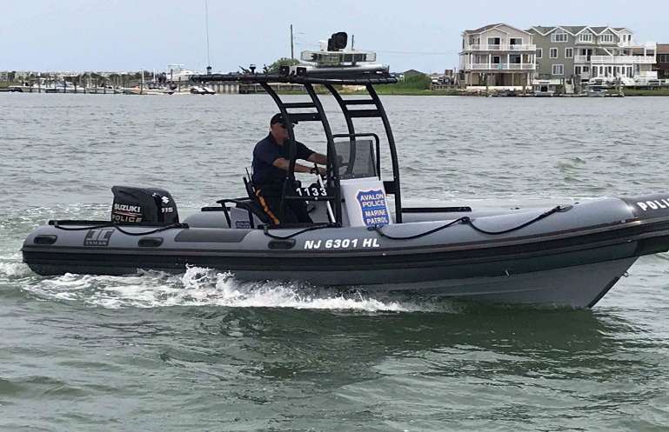

**COMMAND AND LEADERSHIP ACADEMY**

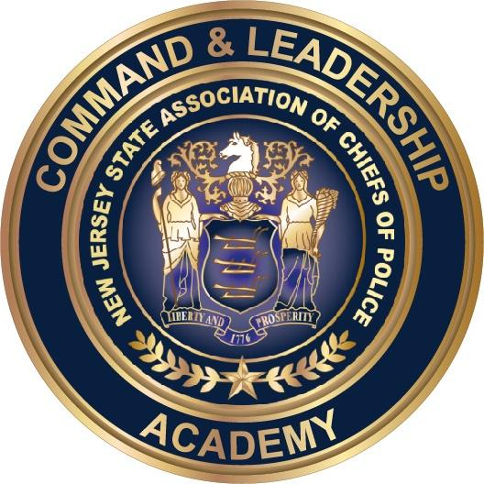

The Command and Leadership Academy is a rigorous, sixteen (16) week course, held once per week, at the Transportation Security Administration Training Center Building 291 E, William J. Hughes Technical Center located by the Atlantic City Airport. It requires full commitment and participation. Supervisory officers are taught complex leadership theories modeled after the fabled West Point Command and Leadership Academy.

In 2018, Chief Christopher was the first in the Avalon Police Department history to attend. Since then, each year one or two command staff or supervisory officers are selected to attend. In 2022, upon promotion to the rank of Captain, Sean McNair attended and graduated.

**JUVENILE JUSTIC REFORM**

Avalon is still feeling the effects of the Cannabis Regulatory Enforcement Assistance and Marketplace Modernization Act (later referred to as CREAMMA) and the New Jersey Attorney General Juvenile Justice Reform Directive.

The CREAMMA law legalized marijuana for adults. For this there was no surprise. However, what the law imposed that was a shock to everyone and still mostly unknown to citizens was it removed any consequences for juveniles found with marijuana and alcohol including being taken into custody, driven home to parents, or charged with a minor offense. It further put restrictions and penalties on law enforcement officer with purpose to prevent detection and apprehension of juveniles with marijuana and alcohol. Officers are now threatened with a crime of the third degree for any of the following: Using the sense of smell to investigate marijuana or alcohol, taking juveniles into custody for underage possession of alcohol and more. This law was created under the pretense that marijuana would merely be legalized for adults but conversely puts juveniles in potential for extreme risk. The consequences of this act are significantly fewer interactions with police and juveniles will occur therefore parents will not know if their children are found with marijuana and alcohol.

The Attorney General of New Jersey further imposed restrictions on police officers which prevent police from identifying juveniles by name, taking into custody or taken home to parents when juveniles are found participating in activity that is dangerous, disruptive, and all borough ordinances. There is also a strong presumption of curbside warnings for disorderly person’s offenses, and some fourth degree crimes. When providing a curbside warning, officers must not take their names, and must merely estimate their gender and race on quarterly reports to the A.G.

**What is being done about it**?

I have personally drafted an eighteen (18) page document which outlines the problems with the law and directives, the issues that shore towns are experiencing, and the solutions needed to resolve it. Additionally, I created a twenty (20) minute video compilation of body worn camera footage of juvenile conduct, complaints, and lack of police response, and forwarded it to Senator’s Mike Testa and James Beach. All endorsed by the Cape May County Chiefs of Police Association. I participated in several meetings with Chiefs of Police, Mayors and lawmakers to voice solutions to the problem. At this time, no action has been taken. Stay tuned!

**STOLEN MOTOR VEHICLES**

There were seven high end motor vehicles stolen throughout Avalon this year. Motor vehicle thefts have been occurring in record numbers state-wide and is certainly not limited to Avalon. There were thousands of stolen motor vehicles throughout the state. Perpetrators are targeting high end motor vehicles. The Avalon Police Detective Division has been investigating these thefts vigorously. The majority of these thefts occurring through accessing unlocked doors.

**ACCREDITATION**

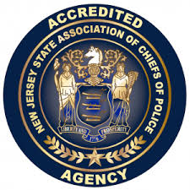

Administered by the New Jersey State Association of Chiefs of Police (NJSACOP), the accreditation program requires agencies to comply with best practice standards in five basic areas: the administrative function, the personnel function, the operations function, the investigative function, and the arrestee/detainee function.

The Avalon Police Department must comply with 105 standards in order to achieve accredited status. Accreditation status lasts for three years, during which the agency must submit annual reports attesting to their continued compliance with those standards under which it was initially accredited*.* Accreditation results in greater accountability within the agency, reduced risk and liability exposure, stronger defense against civil lawsuits, increased community advocacy, and more confidence in the agency’s ability to operate efficiently and respond to community needs.

The Administrative Sergeant, Eric Heisman is responsible for maintaining accreditation records and reports. We work with an accreditation consultant, Chris Winters, who advises the department on best practices and standards. Chris is a retired Lieutenant from the Lower Township Police Department. He then worked as an undersheriff with the Cape May County Sheriff’s Department, and is currently working with J.A. Montgomery as a risk consultant.

The Avalon Police Department was awarded accreditation status in June 2022. This is the Departments third re-accreditation. Only 5% of New Jersey police departments have been re-accredited for the third time.

**ACCREDITED CHIEF EXECUTIVE**

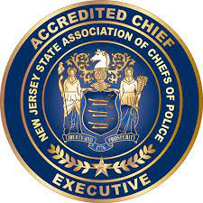

Chief Christopher has become the first Chief in A.P.D. history to achieve accredited status from the New Jersey Association of Chiefs of Police Associations, Accredited Chief Executive Program.

This program encourages continuing education and professional development through attaining sanctioned benchmarks. Some of the benchmarks the Chief attained to obtain this accreditation are: The NJSACOP West Point Command and Leadership program, New Police Chiefs orientation, the Police Executive institute, as well as possessing an Associate degree in criminal justice. Accreditation status is for a period of three years. To maintain the status, the Chief must continue to further education yearly by completing various training courses.

**DEPARTMENT TRAINING 2022**

A breakdown of the schools attended during 2022 by members of this department are as follows:

|  |  |  |
| --- | --- | --- |
| SCHOOL | PERSONNEL | HOURS |
| Command/Leadership | 1 | 136 |
| ALCO-Test Recertification | 9 | 18 |
| ALCO-Test Initial | 1 | 32 |
| ICAT/ABLE | 21 | 352 |
| PT Instructor | 2 | 32 |
| Methods of Instruction | 1 | 48 |
| Glock Armorer | 1 | 8 |
| Front Line Supervision | 2 | 32 |
| Field training officer | 1 | 16 |
| Offender Watch | 1 | 4 |
| OC Spray | 1 | 8 |
| Seasonal officer training | 8 | 8 |
| Title 39 Motor Vehicle | 1 | 8 |
| Wildwood Table Exercise | 1 | 6 |
| Bomb Training | 4 | 3 |
| Sig Armorer | 2 | 16 |
| Career Survival Supervisors | 2 | 8 |
| Career Survival Officers | 2 | 16 |
| Mobile Field Force | 1 | 4 |
| Conflict Resolutions | 1 | 24 |
| Search and Seizure | 3 | 42 |
| Gracie Training | 2 | 64 |
| Agency Training/In-service | 21 | 168 |
| Rifle Course | 2 | 64 |
| Crisis Intervention | 2 | 160 |
| Tactical Combat Casualty Care | 2 | 32 |
| Management of Aggressive Behavior | 2 | 8 |
|  | **TOTAL** | **1317** |

In addition to the above, each officer (21) had approximately 12 hours of firearms training (Including both handgun and long gun – Department 252 hours), representing **a total of 1569 hours of training for 2022.**

**Training for summer personnel**

**Special Officer Class II** Hours

Brendan Eagan 320

Brandon McKeirnan 320

Jack Washington 320

**Special Officer Class I**

Sarah Frazier 80

Alec Elia 80

Amy Escalante 80

**Total Department training hours 4086**

|  |  |  |
| --- | --- | --- |
|  |  |  |
|  |  |  |

**INSTRUCTION BY POLICE PERSONNEL**

Some full-time officers become certified by the New Jersey Police Training Commission to instruct officers and academy recruits. Officers of the Avalon Police Department are certified in a variety of courses such as: firearms, physical fitness, vehicle operations, patrol tactics, defensive tactics, use of force, handcuffing, O.C. (pepper) spray, resiliency, active bystander for law enforcement (A.B.L.E), integrated commination assessment and tactics (I.C.A.T.) and more.

**Officer Hours**

|  |  |
| --- | --- |
| Sgt. Bowers  Sgt. Ardelean  Sgt. Armstrong | 23  60.5  35 |
| Sgt. Sykes  Ptlm. Peahota | 55  86.5 |
| Det. Savini | 86.5 |
| Ptlm. Hill  Sgt. Robinson  Ptlm. Baile | 68  35  57.5 |
| Ptlm. DeCesero  Ptlm. M. Glassford | 130  187 |
| Ptlm. Brady | 276.5 |
|  |  |



Law Enforcement against Drugs, is an organization designed to help educate and prevent youth from participating in dangerous activity such as drug use, drug related crimes, peer to peer/cyber bullying and violence. L.E.A.D is a rapidly growing drug and violence prevention program in the United States and is currently certified with instructors in forty (40) states. L.E.A.D. promotes positive, pro-social attitudes and behaviors as well as resistance to negative peer pressure and resistance to substance abuse and conflict.

The program will discuss the negative norms that are promoted by society as well as the positive norms that we need to encourage. Throughout the course of the year, the L.E.A.D. officer will teach the 6th grade students, ten (10) different lessons which will focus on various topics such as setting reachable goals, making responsible decisions, identifying and managing emotions, effects of alcohol and nicotine and drug use. These lessons will be taught in a classroom setting and each lesson involves fun, informative activities such as visual displays, role-play scenarios, posters, and board games. The L.E.A.D. officer will be a role model for the students throughout the weeks and help develop good character by teaching positive attitudes, beliefs, and behaviors.

The first day of class occurred on January 27, 2022. (Picture below is Sgt. Matt Ardelean and the 6th grade class)

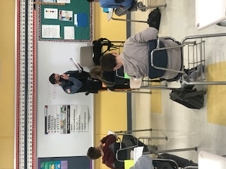

**COMMUNITY OUTREACH**

Community Outreach will always be a top priority for this police department. It is imperative that we engage with the community and get to know the citizens on a personnal level. When positive relationships are built, we establish the mutual trust and respect of the people we serve. It will enable dialouge and partnerships to further enable positive change. The A.P.D participated in many events this year.

The department had our Coffee with a Cop several times this year along with our very successful Christmas Toy Drive. We had officers join in the Law Enforcement Torch Run, Police Unity Tour and the second annual softball game of police vs fire department (police won again). The police department actively participated in borough events such as: National Night Out, Trunk-or-Treat, and Festive Friday-Snow-fest Saturday. Adding into the mix The Bike Safety Initiative, Pickle ball and other activities made it a great year to see so many friends and families out enjoying our community!

**SENIOR ALONE PROGRAM**

The senior along program is supervised by Patrolman Robert Hampf. Ptlm. Hampf has run the program for almost 8 years now. The program allows seniors and family members of seniors living alone within the borough of Avalon to know that someone is there for them if needed. Seniors that wish to register for the program will call into dispatch on a daily basis prior to 11 am. If no call is received, an officer will be dispatched to check on them. Officers will ensure the well-being of the senior and advise family members of any concerns.

**2nd ANNUAL AVALON POLICE vs AVALON FIREMAN SOFTBALL GAME**

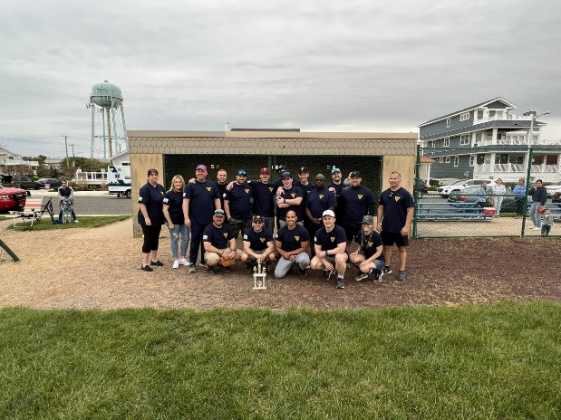

The Avalon Police Department competed against the Avalon Fire Department and Avalon EMS in the Second Annual Avalon First Responders Softball Game. The Police Department's bats were too hot for the Fire Department to handle which resulted in a 24-13 victory. The Police Department found that no practice was the determining factor in their victory.

**SPECIAL OLYMPICS TORCH RUN**

Ptlm. Hill, Ptlm. Stoltenberg, Det. Savini and Admin. Assist. Hanger participated in the 2022 Special Olympics Torch Run.

**COFFEE WITH A COP**

This year Coffee with a Cop was back a couple times. Sgt. Bowers and Ptlm. Baile along with many Avalon officers stopped by local businesses such as Isabel’s and the Fishin’ Pier Grille enjoying time with the staff and citizens. The other events were at the Avalon’s Art and Seafood Festival and during the Turkey Trot on Snow fest Saturday with coffee and pastries provided by WAWA.

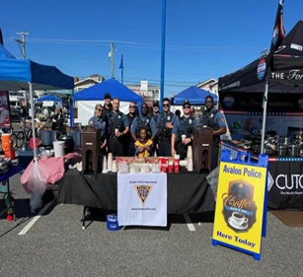 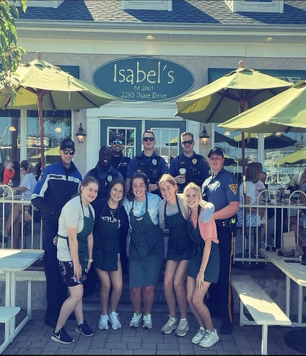

**NATIONAL NIGHT OUT**

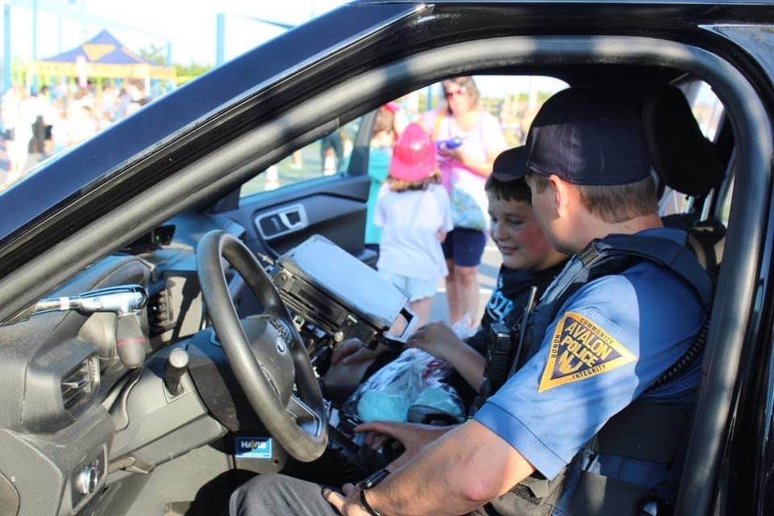





National Night Out was a success once again. It is a fun way to give back to the community and build relationships. This Sgt. Eric Heisman, Sgt. Greg Armstrong, and Detective Pete Savini cooked over 500 hotdogs and provided to everyone free of charge. Special officers Alexis Hagner greeted citizens and provided everyone with A.P.D logo gear including: cups, footballs, glasses, stickers and more. Sgt. Matt Ardelean worked an obstacle course using a tricycle and DWI simulated impaired driving goggles. Citizens and kids would wear the goggles and attempt to navigate the course. This course demonstrated the dangers of performing a simple task when you are impaired or under the influence.

**POLICE UNITY TOUR**

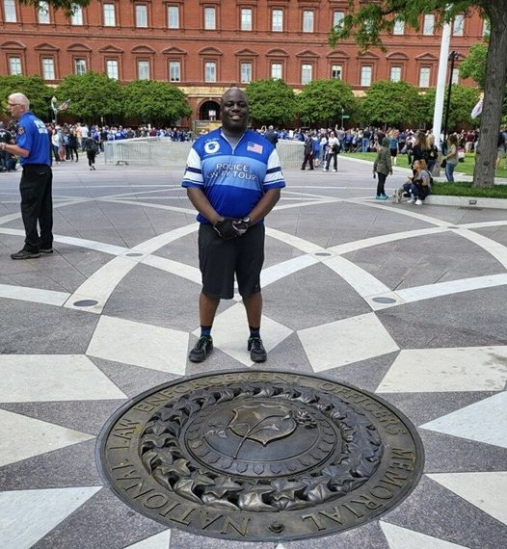

After 160 miles of riding in the Police Unity Tour, Avalon Police Department’s Ptlm. Baile arrived at the National Law Enforcement Officers Memorial in Washington D.C. Great job!

**PICKLE WITH THE POLICE**

Avalon Police hosted its first annual “Pickle with the Police”. It was a great turnout. Officers teamed up with different members of the community. While some had experience others not so much. The members of the community made it a fun filled afternoon with an occasional dink. Thank you to everyone that participated in the event!

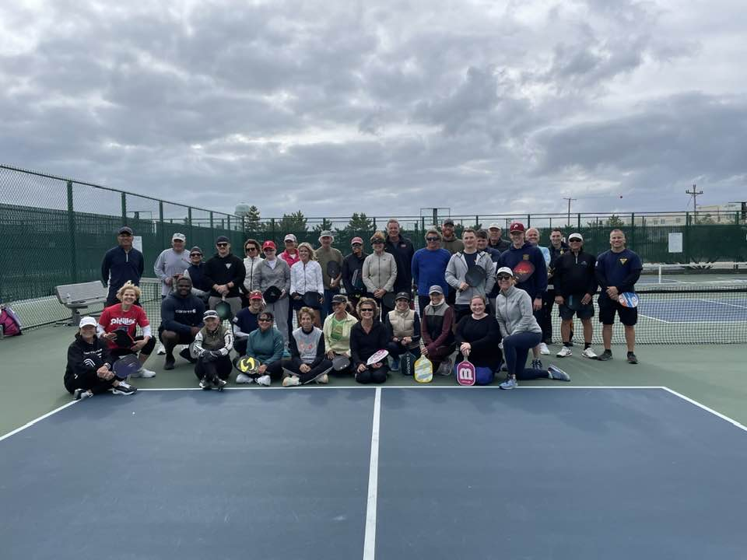

**Sun & Sand 5K in North Wildwood**

The Avalon Police Department showed up and put out in the Sun & Sand 5k in North Wildwood. The team was made up of Sgt. Robinson, Sgt. Ardelean, Det. Savini, Ptlm. Featherer and Ptlm. Prickett. Avalon Police took second place in the overall team standings. Great job to all involved and thank you to the North Wildwood Police Department for hosting a great race!

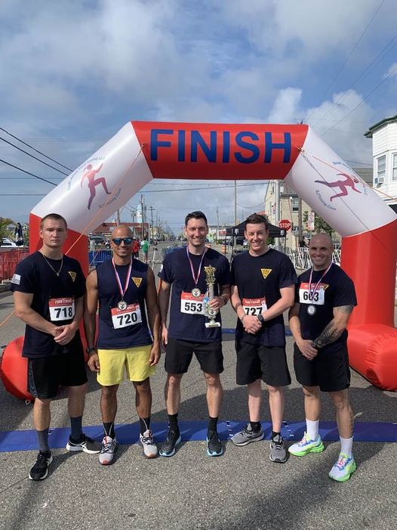

**TRUNK-OR-TREAT**

Avalon’s Trunk-or-Treat had another amazing turnout. Students at the Avalon Elementary School were given character choices for the department to dress up as, and Pokemon was the overwhelming winner!

Det. Armstrong as “Ash” and special officer Alexis Hagner as “Duskull” did a great job, and put a good deal of effort decorating one of the patrol vehicles and getting into character for the event. The kids and their parents appreciated it. Fun was had by all!

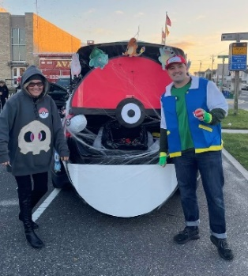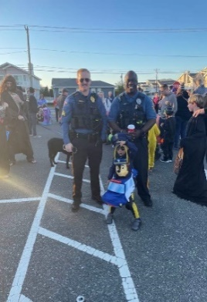 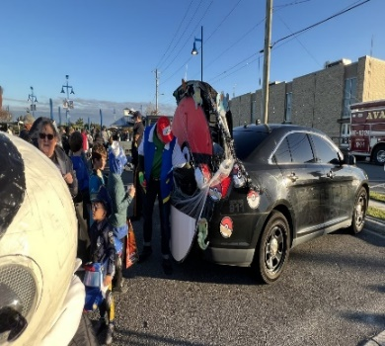 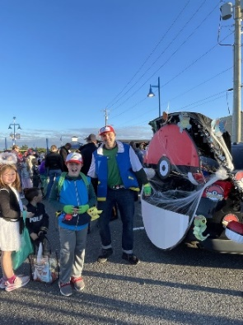

**FESTIVE FRIDAY & SNOWFEST SATURDAY**

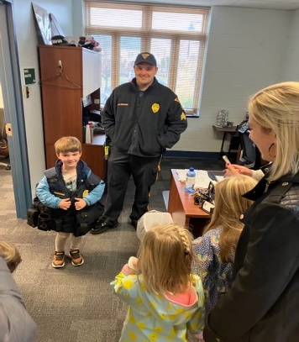 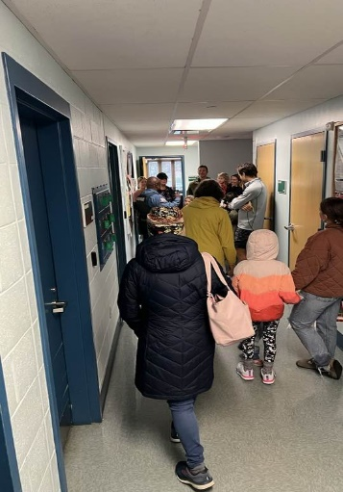 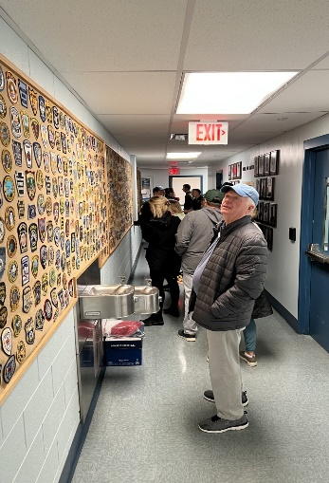

Thanksgiving Weekend is a busy time of the year in Avalon. The shoppers and families in town made it through the periods of rain during the long weekend out shopping and enjoying the festivities going on in town for the holidays. Sgt. Eric Heisman, Sgt. Greg Armstrong, Ptlm. Mark Glassford, Ptlm. Joe Stoltenberg, Det. Pete Savini, and Special Officer Hagner cooked and wrapped 1000 hotdogs, while families took tours of The Avalon Police Department.

**2022 CHRISTMAS TOY DRIVE**

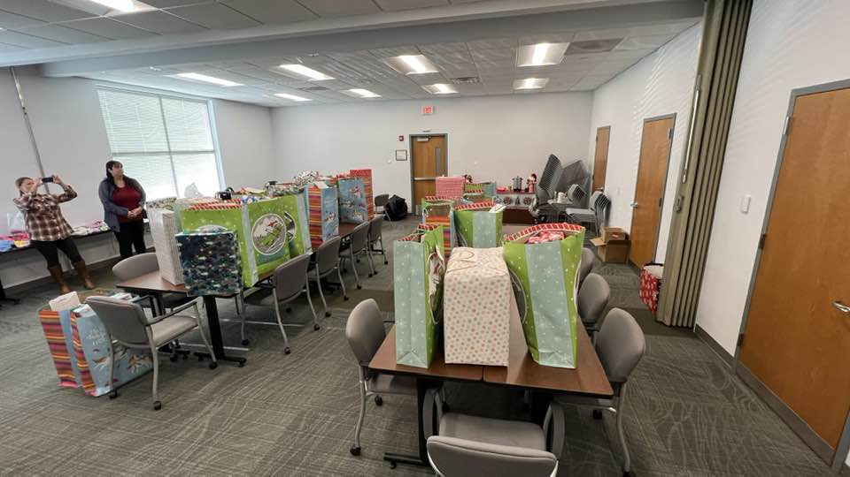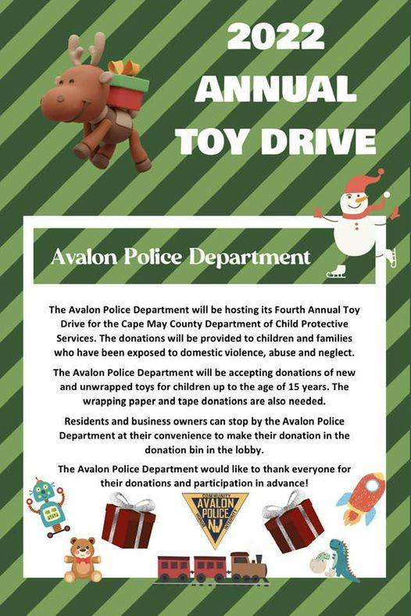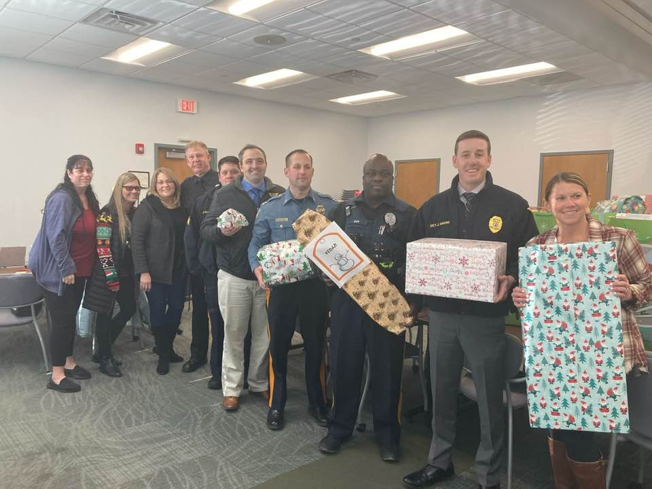

The Avalon Police Department received approximately 300 toys donated for our toy drive. Dawn Brady, Alexis Hagner, and Debbie Foley meticulously wrapped each gift. Sgt. McNair, Sgt. Heisman, Det. Sgt. Armstrong, Det. Savini, Ptlm. Baile, Dawn Brady, Deborah Foley and Alexis Hagner delivered presents to the Department of Child Protection and Permanency. We are extremely grateful to the businesses and people that donated. Thank you to all that took the time to be a part of the toy drive! Also pictured is retired Avalon P.D. Sgt. Al Gombar, currently working security at the D.C.P.P.

**AVALON POLICE OFFICERS AND COMMUNITY MEMBERS**

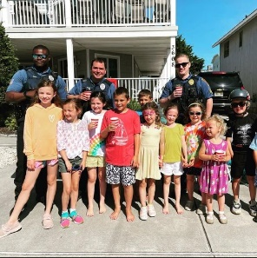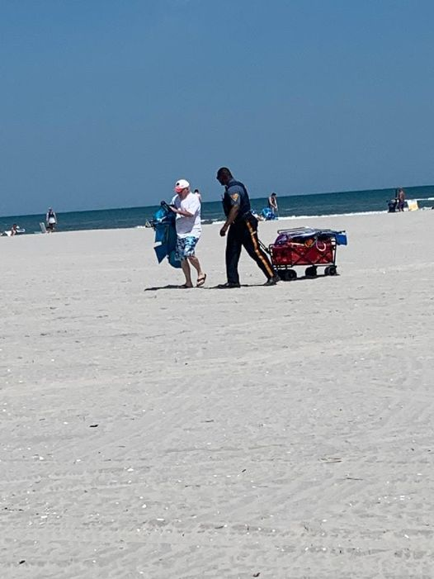 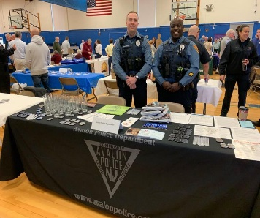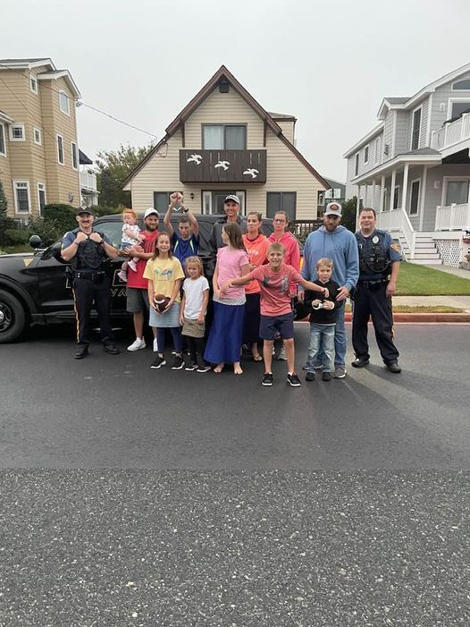

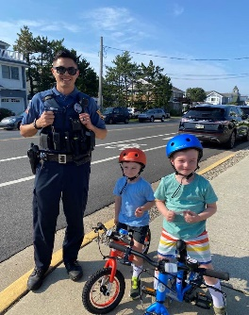 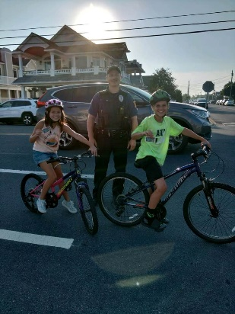

Everything from lemonade stands, walks on the beach, community meet & greets, summer camp tours and ongoing bicycle safety, along with all the previously mentioned events, are what make Avalon Police Department and members of our community what it is today. Thank you!

**Bicycle safety initiative**

In addition to enforcement stops for violations, officers wanted to recognize citizens that follow all bike laws all while promoting local businesses. For the second year officers would conduct stops of individuals that were riding their bike while following all bike laws and providing them with a coupon to Circle pizza for a free slice of pizza.

**Community outreach report completed by Alexis Hagner**

**RETIREMENT**

On June 1, 2022, Captain John Roscoe retired from law enforcement after thirty (30) years with the Borough of Avalon. Captain Roscoe started in 1992 as a dispatcher and special officer. In 1994 he was hired as a full-time police officer. In 2011, he was promoted to Sergeant. In 2018, he was promoted to Captain of Police.

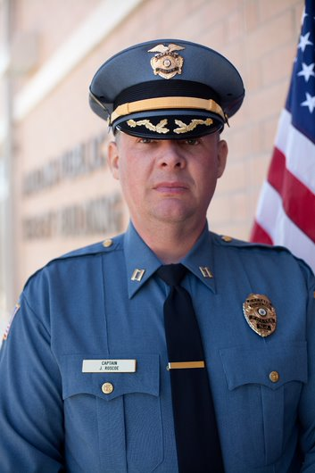

**NEW HIRED OFFICERS**

**Owen Prickett**

On January 09, 2022, Owen Pricket was selected to be the next full time officer and began the Cape May County Police Acadmy, one of only two police academies in the state that require recruits to live at the barracks for 4 ½ months. Owen is a resident of Dennis Twp N. J. On June 14, 2022 Owen graduated. The sweaing in of his oath of office was conducted by the Honorable Mayor Martin Pagliughi. Pictured below is Chief Christopher pinning Owen’s badge on after the swearing in.

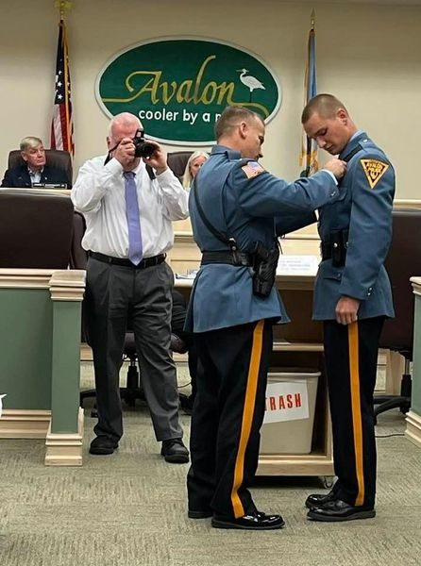

**Kyle Roscoe**

On July 14, 2022, Kyle Roscoe, son of retired Captain John Roscoe was hired as a full-time officer and began the police academy. Kyle graduated on January 13, 2023. His sweaing in by Honorable Mayor Martin Pagluighi is scheduled for February 8, 2023. Pictured below is Retired Captain John Roscoe pinning the badge on Kyle at the Police Academy graduation ceremony.

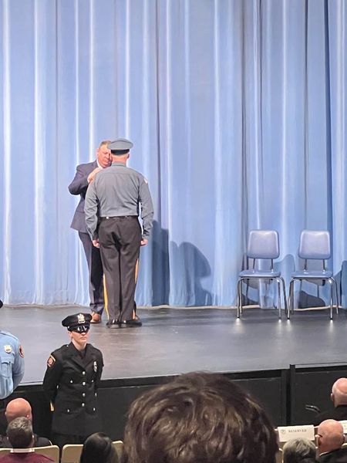 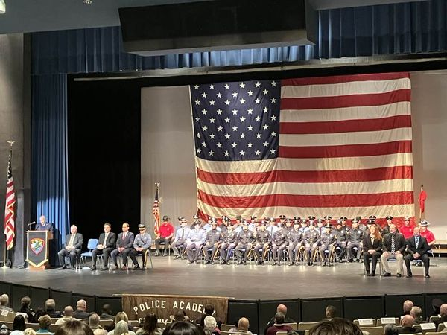

**PROMOTIONS**

**Sean McNair to Captain of Police**

On May 25, 2022, Sean McNair was officially sworn-in to the rank of Police Captain. Pictured below is Captain McNair taking his oath of office with his wife Robyn holding the bible.

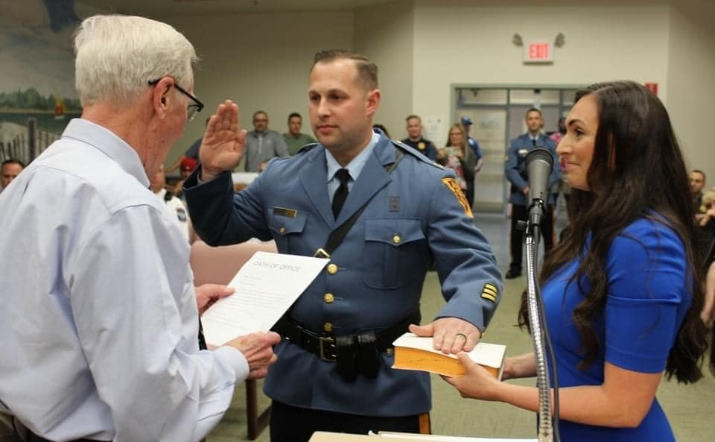

**Greg Armstrong and Matt Ardelean to Sergeant**

On March 23, 2022, and May 25, 2022 respectively, Detective Greg Armstrong and Matt Ardelean were sworn-in to the rank of Sergeant. Sgt. Armstrong was assigned to the Detective bureau, and Sgt. Ardelean was assigned to patrol squad 4. Pictured below is Sgt. Armstrong swearing his oath of office with his wife Ashly holding the bible and Chief Christopher pinning badge on Sgt. Ardelean.

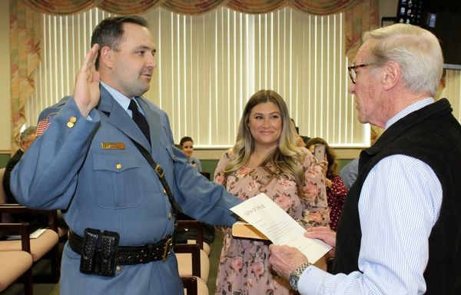 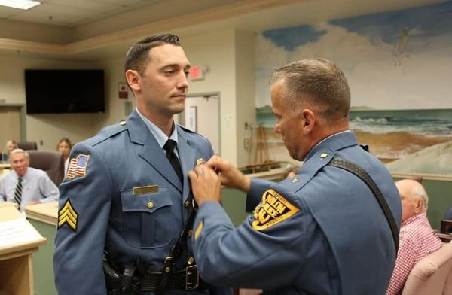

**AWARDS AND RECOGNITION**

YEARS OF SERVICE AWARD

Records Administrator Dawn Brady has reached 20 years with Avalon.

Sgt. Matt Sykes, Sgt. Eric Heisman and Patrolman Tu-Juan Baile have been officers with the department for 15 years.

No Sick Time Usage in the 2022 Calendar Year

**Sgt. Matthew Ardelean Dedication to Duty Award**

Sgt. Matthew Ardelean is recognized for his sincere dedication to service and his fellow employees, by faithful attendance to duty on each and every day scheduled to work in the 2022 calendar year.

**Ptlm. Nicholas Brady Dedication to Duty Award**

Ptlm. Nicholas Brady is recognized for his sincere dedication to service and his fellow employees, by faithful attendance to duty on each and every day scheduled to work in the 2022 calendar year.

**Admin Assistant and Special Officer Alexis Hagner Dedication to Duty Award**

Administration Assistant Alexis Hagner is recognized for her sincere dedication to service and her fellow employees, by faithful attendance to duty on each and every day scheduled to work in the 2022 calendar year.

**Life Saving Awards**

**Ptlm. Lukas Hill #186 Life Saving Award**

On July 4, 2022, Ptlm. Hill responded to the 39th Street tennis courts for an unconscious and unresponsive male. He immediately assessed the patient began CPR, then administered one shock by way of an AED, then resumed CPR. After approximately 80 chest compressions the patient began to breathe on his own. The patient was immediately transported to Cape Regional Medical Center where it was later advised the patient was alert and conscious. Ptlm. Hill’s quick response and actions resulted in saving the man’s life.

**Patrolman Tu-Juan Baile #164 Life Saving Award**

**Patrolman Joseph Stoltenberg #188 Life Saving Award**

On February 17, 2022, Ptlm. Baile and Ptlm. Stoltenberg responded to the 22nd Street boardwalk for an unconscious and unresponsive male. Ptlm. Stoltenberg assessed the patient and began CPR. Ptlm. Baile applied the AED and administered one shock. The patient was then transported to Atlantic City Medical Center. A few days later, the patient and his wife arrived at police headquarters to thank all emergency personnel for their life saving efforts. The quick response and actions of Ptlm. Baile and Ptlm. Stoltenberg resulted in saving the man’s life.

**Detective James Savini Distinguished Achievement Award**

On June 29th, 2022 Detective Savini began investigating a sexual assault that allegedly occurred over Memorial Day weekend. He put his personal life on hold to urgently investigate so perishable evidence was not lost. He secured electronic evidence and extensive interview statements and quickly identified the suspect. Through further diligent investigation it was determined that the suspect purposely drove from Pennsylvania to Avalon to commit an assault against a minor. Det. Savini obtained enough evidence and probable cause to charge the suspect and obtain an indictment.

**Citizens Commendation**

**Wawa- Avalon**

The Avalon Police Department would like to recognize and thank Wawa for their sincere generosity and continued support of the community and the police department. During the calendar year of 2022, Wawa donated twenty-one outer carrier uniform vests to outfit all full-time officers. Wawa also donated coffee and pastries for two Cops and Coffee programs and hundreds of hotdogs for community outreach events. These generous contributions caused these events to be successful and confirms Wawa’s commitment to the community and police department.

**GOALS AND FUTURE OBJECTIVES**

**Recruiting**

As mentioned above, it has become increasingly difficult to attract qualified people to the positions of full-time and special officers. It is imperative that only the most qualified people, with impeccable character be chosen for these positions. Employing the wrong people will have lost lasting detrimental effects that can tarnish the good reputation of the department and be extremely costly in lawsuits. The A.P.D. recruiting unit will attend various college job fairs locally and in the Tri-State area. We will expand our advertising and spend significant time and resources to seek out and find the best applicants.

**Retention of officers**

Once we select the best person for the positions, retention of employees becoming equally important. Avalon invests a lot of time and money into each officer that is hired. It costs approximately $35,000 of training before an officer works the first day of solo patrol. In 2022, the Borough of Avalon took unprecedented action to level the pay disparity between Avalon Police Officers and local surrounding police departments in an effort to retain officers. 25 years ago, it was commonly known that by the third year mark, it didn’t benefit officers to leave for other departments. Unfortunately that is no longer the case. Unfortunately, in 2022 we lost another young talented officer to another police department with higher pay and opportunities.

**Juvenile Justice Reform**

Until the Governor of New Jersey and Attorney General amend laws and directives relating to juvenile delinquency, marijuana and alcohol possession and consumption, and disorderly conduct, I will continue to voice my objection and strive for solutions. The laws and directives, as they are currently written, make juveniles less safe and parents less informed. The state needs to remove the threat of third degree criminal charges for deprivation of civil rights against officers that are merely trying to investigate juveniles that possess marijuana and alcohol. The state needs to remove alcohol from the Cannabis Regulatory Enforcement Assistance and Marketplace Modernization Act so that police officers can take appropriate action when juveniles are found with alcohol.

**Community Outreach**

We will continue to strive for innovative ways to connect with the community. As seen in 2022, the Avalon Police Department hosted the first ever, “Pickle with the Police”. Recognizing that pickle ball is the fastest growing sport in America and in Avalon, officers had a fun day with the community playing pickle ball together. The officers of this department are committed to community engagement.

**CONCLUSION**

Thank you for taking the time to review the Avalon Police Department 2022 Annual report. It is an honor to serve the Borough of Avalon and lead the best department in the state.

Respectfully,

Jeff Christopher

Chief of Police