AVALON POLICE DEPARTMENT
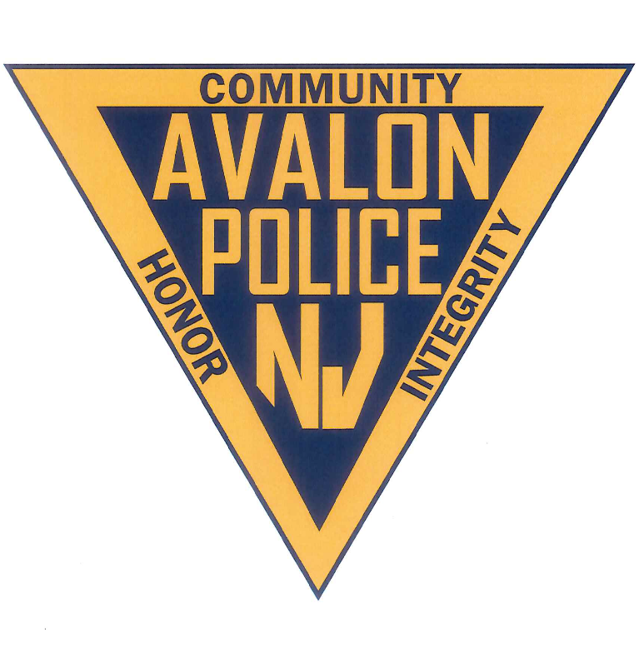
2020 Annual Report
Prepared by:
Jeffrey R. Christopher
Chief of Police

Preface
To: Mayor Martin L. Pagliughi, Borough Council President John McCorristin, Council Vice President Barbara Juzaitis, Councilwoman Dr. Nancy Hudanich Ed. D, Councilman James Deever, and Councilman Sam Wierman
The Avalon Police Department Annual Report is prepared to provide the yearly statistics and activity performed by the officers and civilian staff. This report will reflect the commitment and dedication to duty of the men and women of this department. In this report you will find information regarding operations, personnel, mission, statistics, community activity, goals and more.
Covid-19 was a major factor in 2020 as compared to previous years. It caused a significant impact on police administration and operations. This unprecedented pandemic drastically changed the way we conducted day to day business. It forced the cancellation of many community outreach events and programs that were intended to build relationships with the community. Patrol tactics were modified and many types of police reports were taken over the phone rather than in person. Training and instructing was either cancelled or conducted virtually.

Despite Covid-19, the police department remained active to ensure public safety and community outreach for residents and visitors.

Jeffrey R. Christopher
Chief of Police

TABLE OF CONTENTS
ORGANIZATIONAL STRUCTURE………………………….…….4
MISSION STATEMENT……………………………………….……..5
PERSONNEL……………………………………………………….…….6, 7
ADMINISTRATION……………………………………………….…..8
PATROL……………………………………………………………….…..9
DETECTIVES……………………………………………………….…….10
DISPATCH……………………………………………………………….11
SPECIAL OFFICERS…………………………………………………..12
SUPPORT STAFF………………………………………………………12
CALLS FOR SERVICE…………………………………………………13, 14
TRAINING………………………………………………………………..15
INSTRUCTORS………………………………………………………….16
COMMAND AND LEADERSHIP …………………………………17
ACCREDITATION………………………………………………………17
HIRED NEW OFFICERS……………………………………………...18
PRESIDENT TRUMP RALLY………………………………………..19
COMMUNITY ACTIVITY…………………………………………….20
AHLOA……………………………………………………………………..24
SWAT………………………………………………………………………24
RECOGNITION/AWARDS………………………………………….25
BICYCLE ENFORCEMENT………………………………………….26
BICYCLE VIOLATIONS……………………………………………….26
GOALS AND OBJECTIVES………………………………………….27
CONCLUSION…………………………………………………………..27
AVALON RESCUE SQUAD REPORT ……………………………28

Organizational structure

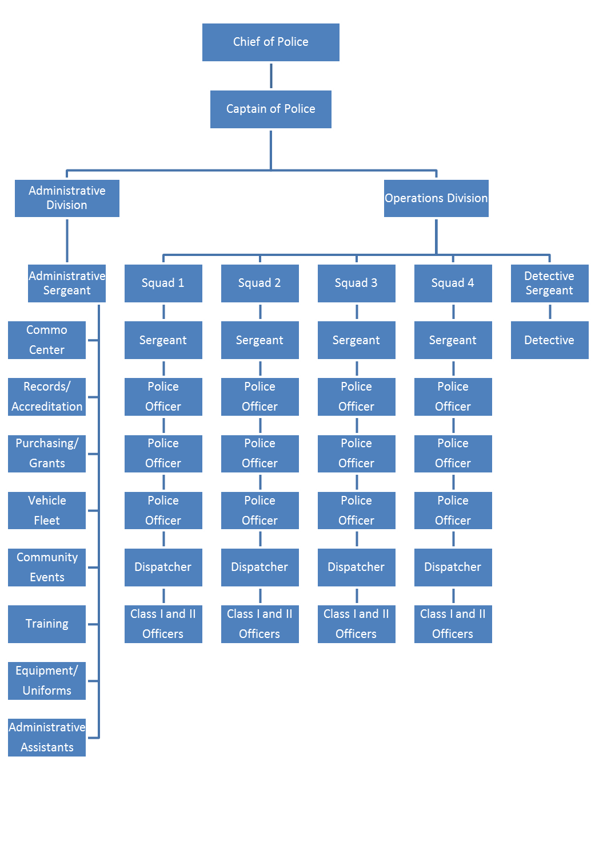

Mission Statement

The mission of the Avalon Police Department is to protect and serve the citizens of Avalon with the utmost professionalism to create a safe environment to live and vacation, by providing equitable enforcement of laws, diligent patrols, thorough investigations and outstanding community relationships”

2020 Personnel

The Avalon Police Department is comprised of twenty one (21) sworn law enforcement officers. One (1) chief of police, one (1) captain, one (1) administrative sergeant, one (1) detective sergeant, four (4) patrol sergeants, one (1) detective, and twelve (12) patrolman. There are four (4) full-time dispatchers and one (1) full-time relief dispatcher. There are three (3) administrative support staff personnel. One (1) administrative assistant, and two (2) records administrators. The police department employs between four (4) to seven (7) part time relief dispatchers. The department utilizes up to twenty two (22) Special Law Enforcement officers

Jeffrey R. Christopher
Chief of Police

John Roscoe
Captain of Police

Sergeants:
David Glassford Patrol
Matthew Sykes Detective Bureau
Eric Heisman Administration
Sean McNair Patrol
William Robinson Patrol
Steve Bowers Patrol

Patrolman: Detective:
Tu-Juan Baile Greg Armstrong Rob Hampf
Zach Saduk
Mark Glassford
Nick Brady
Anthony DeCesero
Matthew Ardelean
Andrew Peahota
Christopher Nazha
James P. Savini
Lukas Hill
Daniel Featherer
Joseph Stoltenberg

dispatchers relief dispatchers support staff
Christine Feketics Nick Herman Dawn Brady
Alyssa Jones Alexandra Carrigan Debbie Foley
Nicholas Seliger Frank DeFeo Alexis Hagner

Special Class 1 police officers

Alexis Hagner also, Administrative Assistant
Ed Szubski marine unit
Robert Armstrong marine unit
Ed Beck marine unit
Alyssa Jones also, dispatcher
Kayla Miller
Frank DeFeo also, relief dispatcher
Jason Hina

Special Class 2 police officers

Joseph Stoltenberg
Joe Nickas
Blake Czajkowski
Michael Schepis
Alex Amato
Christian Pascal
Dominic Grassi

Administration

The chief of police is the head of the Avalon Police Department and is responsible for the day to day operations and to administer and enforce rules and regulations of the department for its efficiency. The chief assigns the duties of personnel and manages the department including purchasing within budgeted resources. The chief sets policy and procedures, issues directives and orders, attendance at borough council meetings, meets with community organizations, and delegate’s authority as appropriate for the efficient operation of the department. The chief of police shall exercise any and all rights, authorities, powers, and responsibilities reserved solely as set forth in NJSA 40A:14-118 and reports to Avalon Borough Council once per month.
The captain of police reports directly to the chief of police. The captains duties include: supervision of the administrative and operations divisions, has charge of the department in the chief’s absence, Internal affairs supervisor, department payroll, department training, approves time off, assigns officers engaged in activities to protect persons and property within the borough, reviews reports, supervises the dispatch center, reviews daily logs, evaluates sergeants, interviews and hires special officers, and performs any duties as needed by the chief.
The administrative sergeant reports to the captain. Primary responsibilities include, but are not limited to: maintaining department accreditation, vehicle fleet management, supervision of the records bureau and communications division. In addition, the admin. sgt. oversees the smooth operation of the police building, computer systems, technology, and assists with training throughout the department.

COVID-19
The Borough of Avalon and the police department felt the effects of Covid-19 immediately. Despite the Governors travel ban, many citizens with second homes in Avalon came to the borough as a way to escape their more populated home towns. This was a confusing time for people. Some expressed concern of enforcement action taken against them for this decision. Many business owners were not permitted to open their doors by Governors’ executive orders. Citizens were concerned about their ability to enjoy the beach and their homes with restrictions on gatherings.
The police department immediately developed a plan to maintain the continuity of operations and avoid a mass outbreak within the department which could severely hinder the ability to provide public safety. In early April, patrol squads were temporarily divided into two groups. One group of two officers would work a normal rotation, the other group would self-quarantine at home and be prepared to report to duty. The intent was to prevent an entire squad of officers from getting exposed to Covid at the same time causing a lack of manpower. Patrol squads operated at minimum staffing for 1 ½ months.
The administrative staff was required to work from home. OPRA regulations were relaxed allowing additional time to complete. They would respond to work whenever it was immediately necessary.
Numerous policies and orders were put into place which remain in effect today. Work stations and vehicles are required to be sanitized at the end of each shift. Officers are required to be on the road unless operationally necessary to prevent gathering in the station house. Masks were purchased and required to be utilized on public contacts. Six feet of separation has become to the norm. The building is periodically sanitized by the use of a mist sprayer.
There were many calls for service that the department had not seen before. Citizens reporting perceived violations of CDC guidelines for which the department had no legal authority to enforce. The department made the decision to educate people. Meetings occurred with business owners and conversations with citizens to explain Governors executive orders.
The summer of 2020 saw an increased number of juvenile gathering at night. A few complaints were received and the observations of officers required immediate action. I requested the Mayor create an executive order closing the beach and boardwalk during the pandemic, from 11:00 pm, until 4:00 am. This had a very positive effect.
As a result of preventative actions, there were zero instances where enforcement action was taken against a citizen or business owner for violations of executive orders.

Patrol

The Patrol Division is the backbone of the Department. The most visible part of the Department and usually the public’s first point of contact. Patrolmen work twelve hours shifts, switching from day to night shift every two weeks. There are four patrol squads. Each has three patrolmen, a dispatcher and is supervised by a patrol sergeant. Patrolmen are always in full dress uniform. There is a minimum of one patrol car required on the road at all times, barring an emergency situation or operational necessity. Primary duties of the patrolmen include: vehicle patrol, criminal law enforcement, traffic enforcement, borough ordinance enforcement, preliminary investigations, responding to various calls for service, security at accident/fire scenes, responding to medical related emergencies, and protection of all persons and property within the borough. On page 14 is a list of generated reports and calls for service that reflect the work of the patrolman for the year 2020.

Patrol officers found themselves in an unprecedented situation as a result of the Covid-19 pandemic. Changes in policy were enacted to immediately protect the department from exposure. Officers were temporarily conducting motor vehicle enforcement on a limited basis as reflected in the yearly summary report. Tactics were modified to protect the officers from exposure to the virus. They were approaching vehicles on the passenger side, while wearing a mask, keeping a minimum of six feet of separation, and avoiding the hand to hand contact typically used on stops. Officers were required to take many non-emergency type police reports over the phone rather than in person. Officers responding to rescue calls were required to remain outside, unless it was immediately necessary for the protection of life.

Detective Bureau Report

In 2020, the Avalon Police Detective Division conducted multiple details and investigations to further the department’s goal to protect the residents and visitors and to ensure the integrity of our establishments serving alcoholic beverages. The detective division conducted eighty-five (85) background checks on taxi-cab drivers, jitney drivers, recreation employees, camp counselors, library staff, and vendors. After these backgrounds are completed, decisions were made to deny or allow the licenses or ability to work.

The detective division conducts background checks for new Class I, Class II, and full-time officers, as well as dispatcher. Eleven (11) background investigations were conducted in 2020, as the police department employs several seasonal officers, relief dispatchers, and hired two (2) new full-time police officers. (Daniel Featherer & Joseph Stoltenberg.)

Prior to the start of the 2020 summer season, the detective division conducted Alcohol Beverage Control inspections of all establishments in the Borough of Avalon who serve alcohol and sell packaged goods. The purpose of these inspections is to ensure that each establishment is in compliance with the local, state, and federal guidelines. The taps of each beer are checked and compared to the corresponding keg to ensure they are serving the correct beverages. Once the inspection is completed, a Division of Alcoholic Beverage Retail Inspection Worksheet is completed. Random inspections are conducted in order to ensure they remain in compliance. Specifically, due to COVID-19 the detective bureau monitored all of the bars making sure they were in compliance with executive orders.

The detective division completed thirty-eight (38) requests for discovery from defense attorneys.
The detective division applies for the Cops-in-Shops grant annually through the New Jersey Division of Alcoholic Beverage Control Commission. Its purpose is to prevent the sale of alcohol to those not of the legal age. Two arrests were made and the grant of $5,280.00 was exhausted.

The detective division is responsible for securely logging and maintaining all evidence, property found for safekeeping, and property that is found or turned in to police officers or brought to police headquarters. Evidence that needs to be tested by an outside laboratory is securely transported by the detective division and carefully documented. Forty-three (43) items were logged into the evidence box, along with additional evidence that was transferred to the CMCPO. There was a total of forty-eight (48) items in the found property box and forty-one (41) recovered bicycles. The detective division and patrol division, rigorously worked in locating the rightful owners of found property. This resulted in the majority of found property being returned to their owners.

The Avalon Police Department participated in Project Medicine Drop. The collected medication, which resulted in forty seven and one half, (47 ½) pounds, is bi-annually turned over to the DEA for destruction. This program allows individuals to anonymously turn in drugs and keep them off of the streets.

The detective division is responsible for conducting background checks for individuals applying for firearms identification cards or permits to purchase or carry handguns. These background checks are conducted in conjunction with the New Jersey State Police Firearms Unit. In 2020, twenty-four (24) firearm investigations were conducted by the detective division. Monitoring and maintaining this information is of the utmost importance in order to provide our officers who respond to daily calls, as well as, the safety of our residents and visitors.

The detective division attends monthly detective meetings at the Cape May County Prosecutor’s Office where detectives countywide are present. Information on intelligence, current cases, and drug trend information is shared to assure the safety of officers countywide. The detective division monitors All Point Bulletins (APB), county intelligence reports, and monthly intelligence reports where the information is shared to our patrol officers for their safety while working the street.

The detectives maintain on-call status on a twenty-four-hour basis and are often called in to investigate crime scenes, conducts forensic interviews, and assist patrol if needed.

In 2020, the detective division assisted with or handled twelve (12) indictable investigations. On March 9, 2020, Det. Sergeant Sykes was covering patrol when he was dispatched to a burglary in progress where four (4) individuals were arrested resulting in twenty six (26) criminal charges. This investigation remains active.

On June 16, 2020, Ptlm. Savini arrested and charged an individual for theft of a motor vehicle and the investigation remains active. The detective division is actively handling a sexual assault. This case remains active.

The detective bureau is currently investigating a theft of a Rolex from a home on September 25, 2020, where two suspects where developed. On November 23, 2020, an individual was arrested and charged with burglary and criminal mischief where multiple motor vehicles were damaged. This investigation remains active.

Detective report submitted by Detective Sergeant Matt Sykes

Dispatch

The Avalon Police Department has a fully equipped dispatch center and is the hub of our department where virtually every call for service originates. Dispatchers are required to perform a full range of radio and telephone operations duties in directing public safety personnel and equipment. They document all calls for service by generating a report on a computer aided dispatch (CAD) report. Dispatchers are trained and certified in 9-1-1 and emergency medical dispatching. The A.P.D. dispatch center is required to answer all 9-1-1 calls for fire and EMS services and appropriately transfer these types of calls to the Cape May County Communications Dispatch center who ultimately handle dispatch duties for the Avalon Volunteer Fire Department and Avalon Rescue. Dispatch for police services is expected to be transitioned to the Cape May County Communication on March 1, 2021
Special Officers___________________________________________________

Special officers are a vital part of the organization. Without special officers, the department would not be able to adequately maintain safety and security of all persons and property within the Borough of Avalon. I cannot express how important these officers are to the Avalon Police Department and the Borough of Avalon. In 2020 we employed eleven (11) special officers. Five (5) Class I officers and six (6) class 2 officers. Only two (2) were returning from the previous year. Current trends in hiring full-time police officers from a pool of certified class 2 officers throughout the state is a major factor. Many class 2 officers work only one (1) summer, then obtain full-time employment elsewhere that prohibits them from returning. Finding and keeping qualified special officers is becoming increasingly difficult. The Avalon Police Department insists on having high standards and employ only those that are qualified that would represent the department in a professional manner.

Additionally, when special officers work for only one (1) year or less due to employment with other agencies, we pursue reimbursement for half of the training expenses, as permitted by law, from the hiring agency. We have been extremely successful over the past few years in receiving all reimbursement.

We utilize special officers in numerous ways including bike patrol, foot patrol, vehicle patrol, marine unit.

Covid-19 had a significant impact on the hiring of special officers. The police academy class scheduled for May was cancelled. This prevented eight individuals from becoming APD special officers for the summer.

Support Staff

Records administrators
The records bureau is responsible for the safekeeping, storage, and managing of all records within the police department. Records includes but is not limited to: criminal investigation reports, traffic reports, accident reports, summons, employee personnel files, training files, medical files, firearms reports, departmental statistics, issuing of equipment and more. The records bureau is responsible for uniform crime reporting, (UCR) to the FBI, NCIC validations on a monthly basis, and reports to the State Police and County Prosecutor’s office. They provide all information regarding discovery and OPRA requests. They have seen an increased number of OPRA requests lately. Dawn Brady and Deborah Foley operate the records bureau.

Administrative Assistant.
Alexis Hagner is the departments’ administrative assistant. Alexis brings a wide range of experience that the department utilized such as administrative skills, class I special officer, and certified dispatcher. The administration has been operating much more efficiently since Alexis has been hired.
Calls for Service 2020

There were 3,311 calls for service. That number reflects any call that was received from a citizen. There were 21,817 incidents. This number is reflected anytime an incident is created in our system. An incident can be anything an officer does in the course of their duties such as a call from citizen as well as self-initiated activity.
Incidents: Enforcement 2018 2019 2020
Motor Vehicle Stops 2901 3211 804
Motor Vehicle Crash 79 76 59
Traffic Summons 817 524 153
Traffic Warnings 2715 2620 736
Warrant Arrest 35 49 15
Parking Summons 896 676 409
Boat Violations Summons 28 25 3
Boat Violations Warning 36 70 19
Boat Assist 29 18 13
Borough Ordinance Summons 407 276 130
Noise Unfounded 96 146 243
Trash Summons Issued 31 47 13
Unlicensed driver 47 24 7
Investigations 124 102 72
Driving While Intoxicated 13 13 12
Suspended Driver 35 31 8
Bicycle Violations – stops 1910 1838 1197
Criminal Mischief 37 32 37
Missing Person 20 17 16
Simple Assault 19 17 4
Aggravated assault 2 2 3
Drug Violation Charges 43 23 9
Possession of CDS 10 9 3
CDS Distribution 1 0 0
Unlawful possession of Weapons 1 0 1
Suicide/attempt 1 3 3
Receiving Stolen Property 1 1 0
Intoxicated Person 53 40 34
Burglary 10 16 21
Lewdness 0 0 0
Harassment 5 6 3
Urinating in Public 69 63 6
Misstating age to gain Alcohol 5 9 4
Terroristic Threats 1 0 1
Domestic Violence 10 1 5
Theft of Services 3 4 2
Resisting Arrest 2 1 3
Underage Alcohol 3 28 27
Open Container of Alcohol 73 65 18
Dogs on Beach 115 88 69
Construction after hours 26 15 8
Fireworks complaint 7 8 4
Shoplifting 0 0 0

Other
Community policing 708 491 58
Business Checks 29504 25370 21096
Property Checks 10990 11163 8533
Burglar Alarms 388 357 272
Assist other agency 64 36 61
Ambulance request 181 397 275
Citizen Complaint 170 162 180
Foot Patrol 2820 3053 2590
Death Investigation 2 2 1
Suspicious incident 40 41 27
Suspicious persons 19 11 22
Suspicious Vehicle 26 31 16
Street lights out 76 56 165
Speed Radar detail 65 44 30
911 investigation 199 159 78
Animal Complaint 150 227 160
Beach Patrol Calls 30 37 50
Bridge Jumpers 80 40 521
Self-initiated construction parking 1597 1464 1032
Prescription drug turn in 23 0 0
Boat problem calls 27 27 43
Suspicious package 1 0 0
Toll Evasion 1 0 0
Boat Trailer Violation 0 3 0
Open Door 135 112 63
Unlocked door 121 59 27
Fire Alarms 122 158 168
Lock-out 86 75 66
Follow up 38 219 78

TRAINING 2020

A breakdown of the schools attended during 2020 by members of this department are as follows:
SCHOOL | PERSONNEL | HOURS
Method of Instruction | 3 | 96
Crash I Investigation | 3 | 88
DWI and Standard Field Test | 2 | 80
Alco-test Operator | 2 | 64
DWI Detection | 4 | 32
Alco-test recertification | 12 | 48
Substance Abuse on JV’s | 2 | 6
CLEAR Sikh Training | 1 | 4
Active Shooter | 2 | 8
Webinar Work Zone Safety | 2 | 4
Command and Leadership | 2 | 320
Jiff Management Protecting Children | 6 | 12
Radar recertification | 1 | 4
Resiliency Training | 2 | 16
IA Training | 4 | 32
JV ECDR Training | 2 | 4
Anti-Police Training | 5 | 10
MEB Instructor | 1 | 16
Monadnock | 6 | 96
Spanish for Officers | 1 | 24
JIFF Risk Management | 8 | 40
Paul Butler Leadership | 11 | 88
Rifle Instructor | 1 | 40
Firearms Instructor | 1 | 40
*Canceled Classes
*Person did not qualify
TOTAL | 54 | 828
344 is total hours of canceled classes
In addition to the above, each officer had approximately 11 hours of firearms training– Department 231 hours, representing a total of 1059 hours of training for 2020.
TRAINING FOR SUMMER PERSONNEL
Special Officer Class II | HOURS
Michael Schepis  Alex Amato  Christian Pascal | 320  320  320
Special Officer Class I
Kayla Miller | 80
Edward Beck  Robert Armstrong | 80  80
Jason Hina  Frank DeFeo | 80  80
Agency Training/In-service | 210
Total SLEO I & II Hours | 1570
Training for the department, which includes both Full-Time and seasonal personnel is: 2629 Hours
INSTRUCTION BY POLICE PERSONNEL
Sgt. Bowers 46.5 hours
Sgt. Glassford 87 hours
Sgt. McNair 93.5 hours
Sgt. Heisman 15 hours
Sgt. Sykes 28 hours
Ptlm. Saduk 90 hours
Sgt. Robinson 56 hours
Ptlm. M. Glassford 111 hours
Ptlm. Ardelean 55 hours
Ptlm. Brady 46.5 hours

Police department instructors provided 649 hours of instruction in 2020
Training hours were significantly less due to COVID-19 and cancellation of spring academy

Training report provided by Sgt. Eric Heisman

Command and Leadership Academy

In January 2020, Captain Roscoe was the second officer in APD history to attend the New Jersey State Association of Chiefs of Police, Command and Leadership Academy. This is a rigorous, sixteen week course, held once per week, and the Transportation Security Administration Training Center Building 291 E, William J. Hughes Technical Center. It requires full commitment and participation. Supervisory officers are trained in complex leadership theories modeled after the fabled West Point Command and Leadership Academy.

Mid-way through the course, covid-19 caused the course to be conducted virtually. Captain Roscoe completed the course in May, earning the title class Valedictorian, a very impressive accomplishment.

In September, Detective Sergeant Matt Sykes began the program. Sgt. Sykes completed it in December.

ACCREDITATION

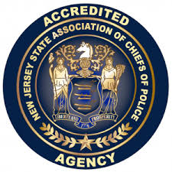

Administered by the New Jersey State Association of Chiefs of Police (NJSACOP), the accreditation program requires agencies to comply with best practice standards in five basic areas: the administrative function, the personnel function, the operations function, the investigative function, and the arrestee/detainee function.
The Avalon Police Department has to comply with 105 standards in order to achieve accredited status. Accreditation is for three years, during which the agency must submit annual reports attesting to their continued compliance with those standards under which it was initially accredited. Accreditation results in greater accountability within the agency, reduced risk and liability exposure, stronger defense against civil lawsuits, increased community advocacy, and more confidence in the agency’s ability to operate efficiently and respond to community needs.
The Avalon Police Department was awarded accreditation status in June 2019. This is the Departments second re-accreditation. Only 5% of New Jersey police departments have been re-accredited for the second time. The APD will be due to re-accreditation in June 2022.

New officers in 2020

The Avalon Police Department had two (2) resignations with the ranks. Hiring the most qualified applicants to represent Avalon in a professional manner is a top priority. A hiring process was conducted to select the most qualified applicant. The hiring process started with a rigorous three (3) hour physical fitness examination conducted by Sgt. Sean McNair at the Avalon Elementary School. Applicants who achieved a passing score moved on to an oral examination to determine their knowledge of criminal justice. Next, an oral interview was conducted to get to know them personally. A thorough background investigation was completed by APD detectives that included criminal and motor vehicle history, home and neighborhood visits, numerous personal and professional references, examination of prior employment personnel files and much more. Then a psychological examination was conducted by a certified Psychologist.
In August 2020, Daniel Featherer was selected and hired. Daniel is thirty one (31) years old. He began is law enforcement career with the Sea Isle City Police Department as a Special Class 2 Police Officer. Not only did he score #1 on the physical fitness examination with a score of 98.5%, his oral examination and interview were impressive. He possess a bachelor’s degree from Wesley College. Daniel began the full-time police academy in August where he also earned the Cape May County Police Academy Physical Fitness award.
On December 22, 2020 Joseph Stoltenberg was selected to fill the second vacancy. Joseph is a resident of Middle Township, Cape May County. He began his law enforcement career in 2017 with the Avalon Police Department as a Class I Police Officer, then in 2019 a Class 2 Police Officer. Joseph is pursuing a bachelor’s degree from William Patterson University which he plans to complete soon. His work history with Avalon reflects superior job performance. Joseph is scheduled to begin the full-time Police Academy on January 17, 2021.
Both officers are outstanding additions to the department.

President Donald J. Trump Rally

On January 28, 2020 President Trump held a rally at the Wildwood Convention Center. This rally was the first of its kind in Cape May County. Due to the expect influx of people attending the rally and security concerns, the Wildwood Police Department and U.S. Secret Service requested officers from surrounding jurisdictions assist with security. Chief Christopher attended intelligence briefings conducted by the United States Secret Service in preparation for the event. Officers were assigned in many ways such as: security of the convention center, traffic details, and crowd control. Avalon officers worked a fifteen (15) hour day, in extreme cold conditions with few breaks to assist in a successful event. SWAT officers were staged and ready. Officers that assisted were:

Chief Jeff Christopher crowd control
Captain John Roscoe crowd control
Sergeant Matt Sykes traffic detail
Patrolman Mark Glassford traffic detail
Patrolman Nick Brady traffic detail
Detective Greg Armstrong traffic detail
Patrolman Zach Saduk SWAT
Patrolman Anthony DeCesero SWAT

Community activity

Unfortunately, most of the APD community outreach was cancelled this year due to Covid-19. Events cancelled included: National Night Out, Trunk or Treat, Police Unity Tour, Cops n Coffee, Special Olympics, Festive Friday, and the police building open house. Fortunately, we remained able to participate in selected events.

EASTER FOOD DRIVE

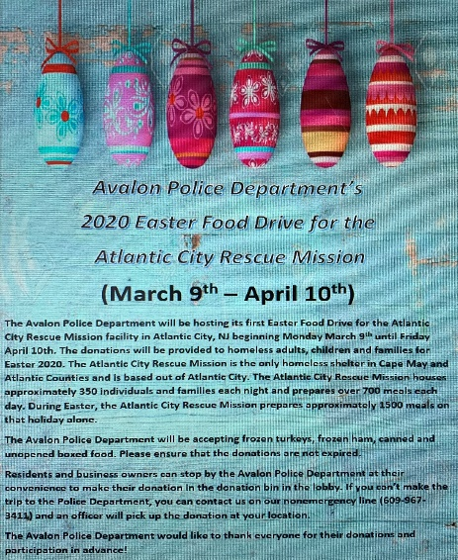
Sgt McNair started heading up the Avalon Police Department Easter Food Drive for 2020 from March 9th – April 10th. Then COVID-19 started rolling in. We received many donations, unfortunately Atlantic City Rescue Mission was unable to receive them due to the pandemic. Not long after, the Tax Collector’s Office started collecting donations for the Cape May County Food Bank. So, Sgt McNair was able to drop off all of the food donations we had received. Great Job all around!

SPECIAL OLYMPICS TORCH RUN

Sgt. Will Robinson, Detective Greg Armstrong, Patrolman James Savini, and Administrative Assistant Alexis Hagner ran the event. The torch run starts at the Cape May Point, and finishes at the police academy located in the Crest Haven Complex. The run raises money and awareness for the New Jersey Special Olympics.

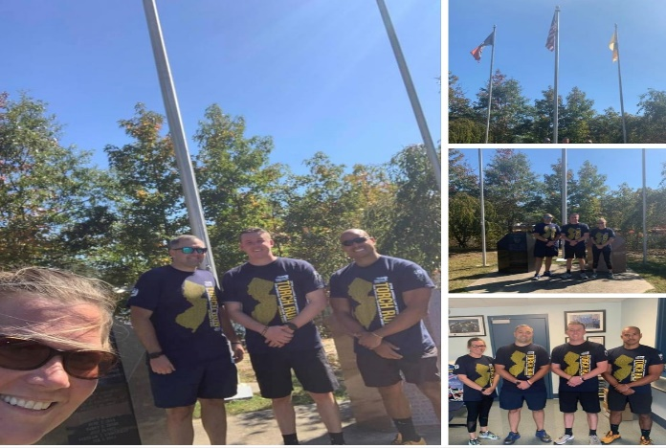

KENNETH WALKER – LOWER TWP PD

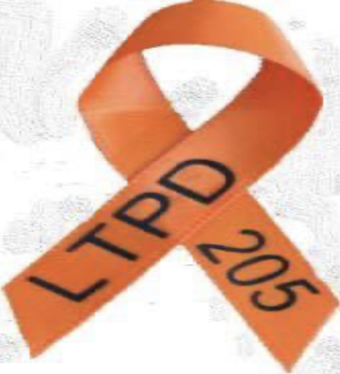
The Avalon Police Department sponsored a fundraiser to assist Kenneth Walker, a Patrolman with the Lower Township Police Department. Kenneth Walker was diagnosed with Leukemia. The donations will help with medical expenses not covered by insurance. Sgt. Sean McNair handled the donations along with the ribbons given out to participators. Officers wore the ribbons during the month of May. Donation Total $1.700+.

BREAST CANCER AWARENESS
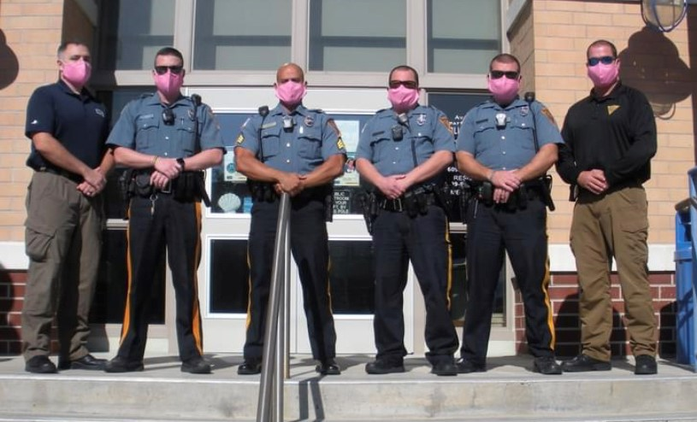
The members of the Avalon Police Department wore high visibility pink face masks during the month of October to raise awareness and show our support to the victims and families that have been impacted by Breast Cancer.

HALLOWEEN

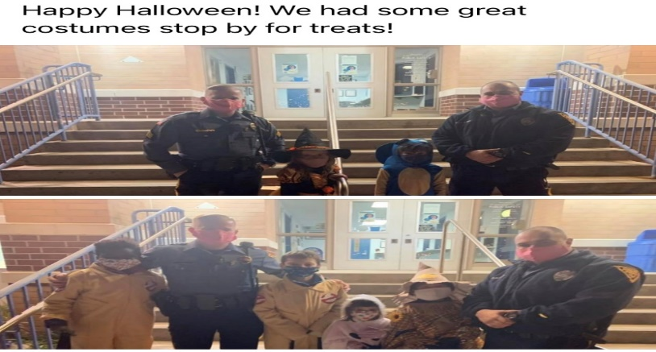
Sgt. Bowers and Ptlm. N. Brady were lucky to work on Halloween night. Here they are with some of Avalon’s finest trick or treaters.

22 PUSH-UP CHALLENGE
On Veterans Day, the APD began the twenty two (22) push-up challenge. This event was conducted virtually by officers recording videos of themselves doing twenty two (22) push-ups, at various locations throughout the borough, then posting videos on the APD social media sites. The 22 push-ups represent the number of veterans that commit suicide everyday as a result of post-traumatic stress disorder. The Avalon Police Department worked in partnership with Commander Tom McCullough and the American Legion post 331 of Stone Harbor. All donations received were provided to Veterans Haven South, a facility located in Hammonton NJ which treats veterans with PTSP.

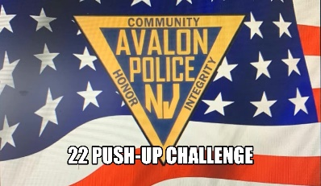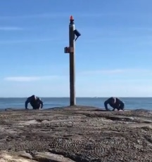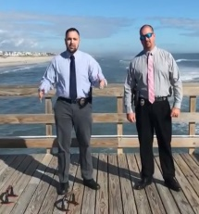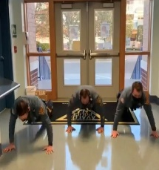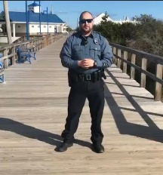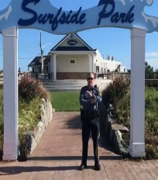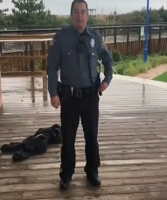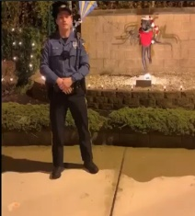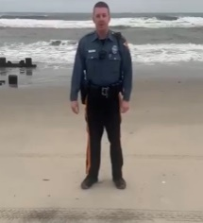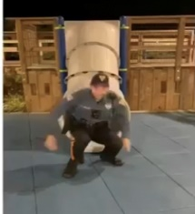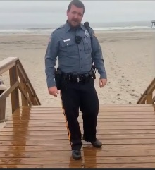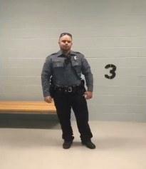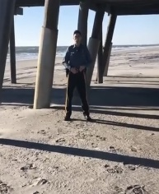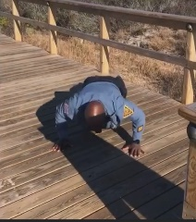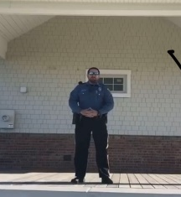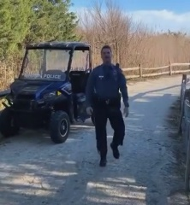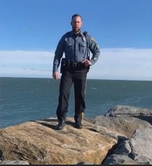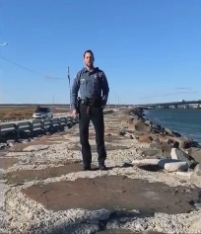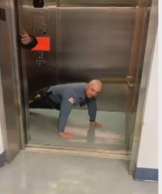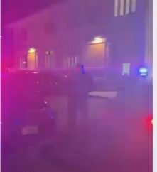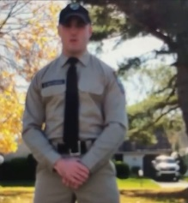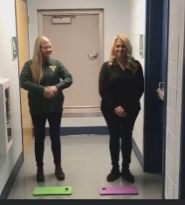

NO SHAVE NOVEMBER

The APD participated in No Shave November. Officers who elected to participate would be required to raise a minimum of $100. All proceeds were given to a local Cape May County resident suffering with breast cancer. The APD raised $2590.00.

CHRISTMAS TOY DRIVE

The Avalon Police Department conducted a “toy drive” for children in need. Toys were donated by Avalon P. D. members, employees of Avalon Borough, local businesses, and citizens. This event far exceeded our expectations. Headed by Sgt. Sean McNair, toys were given to the local office of the Division of Child Protection and Permanency. (Formerly Division of Youth and Family Services, DYFS). APD administrative staff, Dawn Brady, Debbie Foley, and Alexis Hagner spent hours and a lot of effort wrapping all gifts. In total, the Avalon Police Department collected over 200 gifts. That allowed for 15 kids to receive 8-10 gifts from Santa. The remainder of the gifts were donated to Cape Assist and Wildwood PD’s Toy Drives.

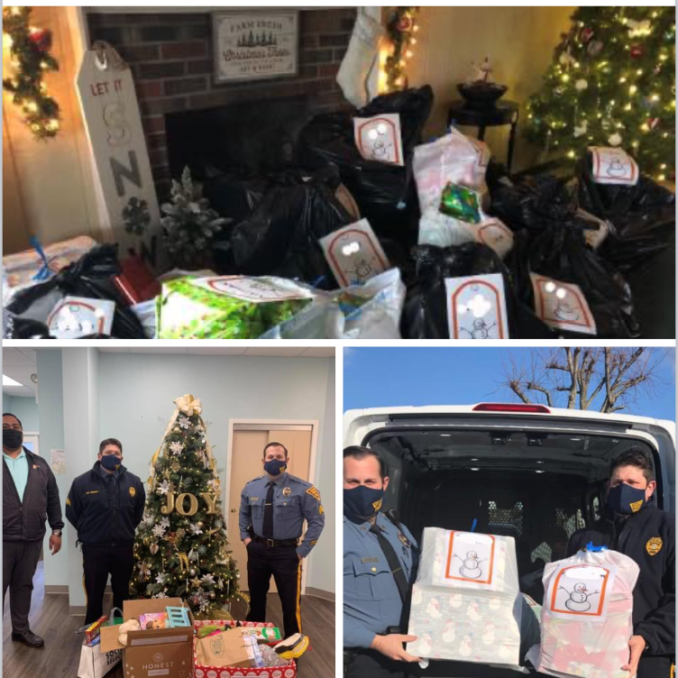
Community outreach report completed by Alexis Hagner

AHLOA

Chief Christopher has monthly meetings with Wayne Popowski, public safety liaison for the Avalon Home and Land Owners Association. These meetings were previously conducted in person, however Covd-19 required they be conducted via email only. Information relating to the police department including: initiatives, plans for the future, and anything of concern to the members is presented and relayed at the monthly AHLOA meeting. It is a great way to keep the citizens informed. In 2020 AHLOA made a donation of a personalized APD corn-hole game set to be used at special events. I appreciate the relationship we have with AHLOA.

S.W.A.T

The Avalon Police Department has two (2) officers on the Cape May County Special Weapons and Tactics Team part time, Zach Saduk and Anthony DeCesero. Their primary responsibility is patrol for the Borough of Avalon, however they are assigned to a twelve (12) hour training once per month. Both officers attended a basic SWAT operator course for five (5) days in Moyock North Carolina, (formerly Blackwater). They respond to any SWAT operation county wide upon a “call out”.

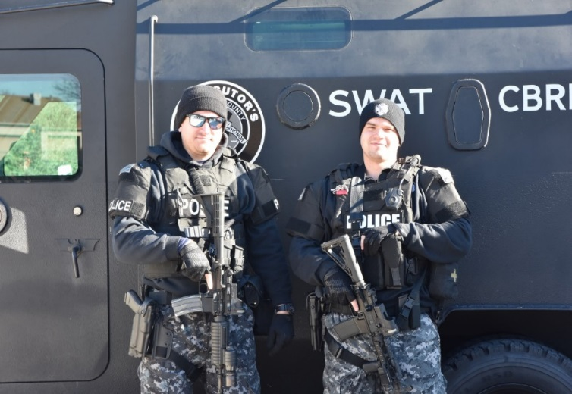

Recognition and Awards

LIFE SAVING AWARD
On May 30, 2020, Ptl. Nick Brady responded to the 200 block of 26th street for two unconscious, unresponsive individuals. Ptl. Brady found both patients with no pulse. He immediately assessed the scene, then began CPR on one of the patients and directed a citizen to begin CPR on the other. Ptl. Brady administered the AED by delivering a shock, then resuming CPR. Moments later, a pulse was obtained on both patients. They were air lifted to the Atlantic City trauma Center and later made a full recovery. It was discovered that the patients were cleaning windows and when moving their ladder made contact with an electrical wire causing both to be electrocuted. The quick response and actions of Ptl. Brady resulted in both patients being alive today.

WALL OF HONOR
In February of 2020, a ‘Wall of Honor’ was completed in the main hallway of the Avalon Police
Department. It honors the dedication and duty of Avalon Police Officers with 25 years or more of service.

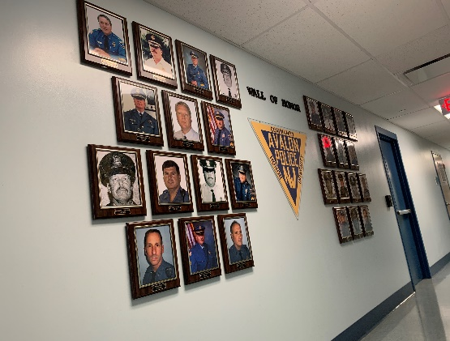
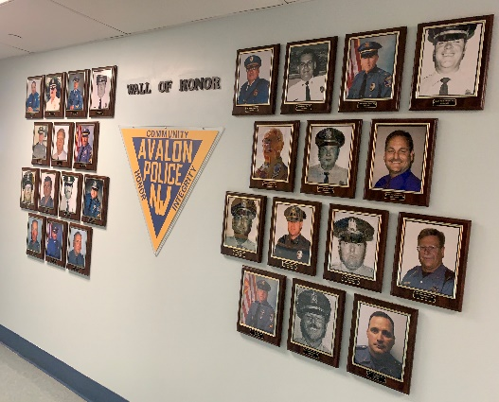

Bicycle Enforcement

Bicycle safety remains a top priority. For many years there has been an increased number of bicycles on the roadway. Many of these bicyclist were violating the laws of the road as well as putting themselves or others in a dangerous situation. We made significant changes to the way we deploy officers and their assignments to combat this problem. The primary strategy is to educate bicyclists on the laws and dangers of operating bikes in an unsafe manner. Safety of the citizens is the driving force behind this initiative. In 2020, there were 1197 stops conducted on bicyclists, resulting in 1880 warnings given, as some stops had multiple bicyclists. Each of these stops resulted in, at minimum, the operator being explained the laws and dangers of unsafe riding, and provided a safety card with important information. These stops also increase officer / citizen contacts which strengthen our community relationships. The number of stops and warnings was slightly less than previous years, primarily due to circumstances related to Covid-19.

Bicycle Violations

GOALS AND OBJECTIVES FOR 2021

Maintaining accreditation is a priority. This is a never ending process of updating policies to the best standards and practices. Accreditation has changed this department into the professional organization it is today. The next accreditation process will be in June of 2022. We are currently on track for complying with each of the standards. We recently purchased an upgrade to our records management system to allow for seamless transition of files to the accreditation committee to streamline the process. The last process resulted in the APD being in 100% compliance. I expect the next process to yield the same results.

Community policing has always been important but it seems as though it is more important today than it was yesterday. As we have seen in 2020 with nationwide protests of police, it is imperative that we maintain the great relationship we have with the community of Avalon. We intend to participate in as many community events as possible to build community trust and relationships. We hope to get back to normal and participate in person, however, we may have to continue adapting to the pandemic and participate virtually. We have many great events planned for 2021.

Purchasing up to date equipment is necessary for efficient operations and complying with best practices. In December of 2020, the APD purchased new body worn cameras for full-time officers. Special officers are also equipped with body cams, however they will be utilizing an older model. We have applied for a grant from the State of New Jersey for the acquisition of additional body cams for the remainder of the force.

CONCLUSION

Thank you for taking the time to review the Avalon Police Department 2020 Annual Report. I would like to thank Mayor Pagliughi, Avalon Borough Council members, Avalon Borough Administrator’s Scott Wahl and Jim Waldron and members of AHLOA for your continued support.

Respectfully Submitted,
Jeffrey R. Christopher
Chief of Police

AVALON RESCUE SQUAD

Annual Report
Member | (Scheduled Hours) Total
Full Time_Berglund, Dan | 2222
Full Time_Cooper, Travis | 1518
Full Time_Dean, Richard E. Jr | 1614
Full Time_Guischard, Ed | 2001
Full Time_Previti, Brianna | 1947
Full Time_Scarpa, Kevin | 1716
Full Time_Schlechtweg, John | 2350
Alexander, Markie | 271
Aquilino, Anthony | 0
Auxer, Michelle | 0
Baldt, T. J. | 924
Bereheiko, Joe | 554
Camp, Robin | 47
DiLuzio, Gina | 0
Kennedy, Derrick | 1055
Makowski, Brittany | 12
Martin, Bill | 538
McCormick, Ann Marie | 84
Nielsen, Keith | 41
Snow, Katie | 379
Raniszewski, Lou | 180
Sacco, Tina | 36
Sasdelli, Lisa | 12
Short, Paul | 729
Turner, William | 422
Washart, Richard | 540
TOTAL: | 18813

CALLS PER MONTH (3 years)
 | JAN | FEB | MAR | APR | MAY | JUN | JUL | AUG | SEP | OCT | NOV | DEC | Total
2020 | 20 | 23 | 29 | 22 | 40 | 89 | 138 | 120 | 70 | 44 | 33 | 30 | 658
2019 | 32 | 31 | 30 | 41 | 64 | 100 | 149 | 129 | 75 | 33 | 22 | 33 | 739
2018 | 32 | 15 | 24 | 21 | 39 | 92 | 127 | 106 | 74 | 47 | 31 | 20 | 628

CALL TYPES
Abdominal Pain |  | 6 |  |  | Man Down |  | 1
Allergies |  | 5 |  |  | Medical Alarm |  | 8
Altered Mental Status |  | 5 |  |  | Medical Emergency |  | 44
Animal Bite |  | 2 |  |  | Motor Vehicle Accident |  | 12
Assault |  | 7 |  |  | Not Applicable |  | 4
Back Pain |  | 1 |  |  | Other |  | 8
Bleeding |  | 16 |  |  | Overdose (Suspected Alcohol) |  | 1
Breathing Problems |  | 2 |  |  | Overdose (Suspected Heroin / Opiate) |  | 1
CO Alarm |  | 8 |  |  | Patient Assist |  | 31
CO Poisoning / Hazmat |  | 3 |  |  | Pedestrian Struck |  | 3
Cardiac – Suspected STEMI |  | 2 |  |  | Psychiatric Problems |  | 14
Cardiac Arrest |  | 1 |  |  | Respiratory Emergency |  | 12
Cardiac Emergency |  | 5 |  |  | Seizures |  | 6
Chest Pain |  | 9 |  |  | Sick Person |  | 11
Choking |  | 4 |  |  | Stand By |  | 3
Convulsions / Seizure |  | 2 |  |  | Stand By – Fire |  | 257
Diabetic Emergency |  | 5 |  |  | Stand By – Police |  | 1
Diabetic Problem |  | 1 |  |  | Stroke/CVA |  | 6
Drowning, Salt water |  | 1 |  |  | Syncope |  | 13
Electrical Shock |  | 2 |  |  | Traffic Accident |  | 4
Fall Victim |  | 77 |  |  | Transport/Transfer |  | 1
Flu-Like Symptoms |  | 1 |  |  | Trauma, Blunt |  | 8
Headache |  | 2 |  |  | Trauma, Head Injury |  | 4
Heart Problems |  | 1 |  |  | Trauma, Pediatric |  | 2
Heat/Cold Exposure |  | 3 |  |  | Trauma, Penetrating |  | 5
Hemorrhage/Laceration |  | 2 |  |  | Trauma, Spinal Cord |  | 1
Hypotension |  | 2 |  |  | Unconscious / Fainting |  | 7
Intoxicated (ETOH) |  | 10 |  |  | Unknown Problems |  | 5
TOTAL: 658

CALL OUTCOMES

Cancelled – Enroute 10
Cancelled – On Scene, No patient contact 9
Cancelled – Police |  | 1
Cancelled – Prior to Response |  | 1
Fire Rehab Assignment |  | 1
Lift Assist |  | 13
Patient Assist |  | 23
Patient Refusal by Action |  | 3
Patient Refused Care |  | 61
Recalled – Fire Department |  | 87
Recalled – Police |  | 2
Recalled other Unit Handled |  | 8
Stand – By 168
Transported By BLS 107
Transported By BLS, ALS Cancelled Prox. 3
Transported By BLS, ALS Cancelled SNN 31
Transported By BLS, ALS Released 2
Transported By BLS, ALS Treat 43
Transported By BLS, ALS Unavailable 1
Treated, Refused AMA 43
Treated, Transferred to Air Medical 6
Treated, Transported by EMS 27
Unfounded 8
TOTAL: 658
Information provided by Rescue Coordinator Kevin Scarpa

