AVALON POLICE DEPARTMENT
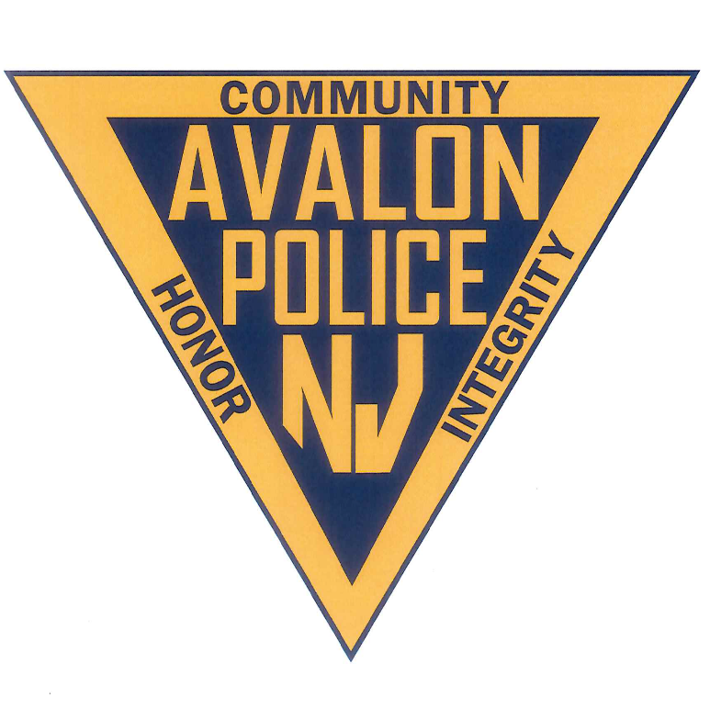
2019 Annual Report
Prepared by:
Jeffrey R. Christopher
Chief of Police

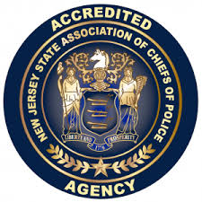
Preface
To: Mayor Martin L. Pagliughi, Borough Council President Nancy Hudanich Ed. D, Council Vice President John McCorristin, Councilman James Deever, Councilwomen Barbara Juzaitis, and Councilman Sam Wierman
The Avalon Police Department annual report is prepared to provide the total yearly statistics and activity performed by the officers and civilian staff. This report will demonstrate the commitment and dedication to duty from the men and women of this department. In this report you will find information regarding operations, personnel, mission, statistics, community activity, goals and more.

Jeffrey R. Christopher
Chief of Police

TABLE OF CONTENTS
ORGANIZATIONAL STRUCTURE………………………….…….4
MISSION STATEMENT……………………………………….……..5
PERSONNEL……………………………………………………….…….6
ADMINISTRATION……………………………………………….…..8
PATROL……………………………………………………………….…..8
DETECTIVES……………………………………………………….…….9
DISPATCH……………………………………………………………….10
SPECIAL OFFICERS…………………………………………………..11
SUPPORT STAFF………………………………………………………11
CALLS FOR SERVICE…………………………………………………13, 14
BICYCLE ENFORCEMENT………………………………………….15
TRAINING………………………………………………………………..15
INSTRUCTORS………………………………………………………….18
ACCREDITATION………………………………………………………19
HIRED NEW OFFICER……………………………………………....20
COMMUNITY ACTIVITY…………………………………………….20
EQUIPMENT…………………………………………………………….25
SWAT………………………………………………………………………26
RECOGNITION/AWARDS………………………………………….27
BICYCLE VIOLATIONS……………………………………………….29
SUMMARY……………………………………………………………….30
GOALS AND OBJECTIVES………………………………………….31
CONCLUSION…………………………………………………………..32

Organizational structure
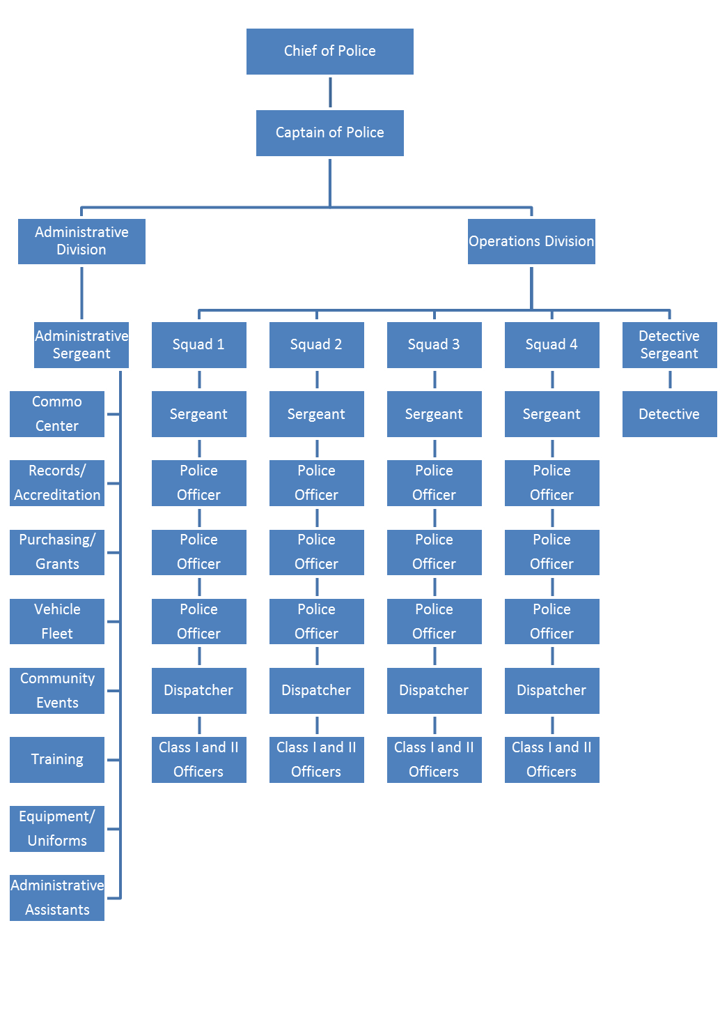

Mission Statement
The mission of the Avalon Police Department is to protect and serve the citizens of Avalon with the utmost professionalism to create a safe environment to live and vacation, by providing equitable enforcement of laws, diligent patrols, thorough investigations and outstanding community relationships”

PERSONNEL
The Avalon Police Department is made up of twenty one (21) sworn law enforcement officers. One (1) Chief of Police, one (1) Captain, one (1) Administrative Sergeant, one (1) Detective Sergeant, four (4) Patrol Sergeants, one (1) Detective, and twelve (12) Patrolman. There are four (4) full-time dispatchers and one (1) full-time relief dispatcher. There are three (3) administrative support staff personnel. One (1) Administrative Assistant, and two (2) Records Administrators. The police department employs between four (4) to seven (7) part time relief dispatchers. The Department utilizes up to twenty two (22) Special Law Enforcement officers

Jeffrey R. Christopher
Chief of Police

John Roscoe
Captain of Police

Sergeants:
David Glassford Patrol
Eric Heisman Administration
Sean McNair Patrol
Matthew Sykes Detective Bureau
William Robinson Patrol
Steve Bowers Patrol

Patrolman: Detective
Tu-Juan Baile Greg Armstrong
Rob Hampf
Zach Saduk
Charles Hewitt
Mark Glassford
Nick Brady
Anthony DeCesero
Matthew Ardelean
Andrew Peahota
James P. Savini
Christopher Nazha
Lukas Hill

Dispatchers Relief Dispatchers Support staff
Christine Feketics Nicholas Herman Dawn Brady
Richard Woolley Alexandra Carrigan Debbie Foley
Nicholas Seliger Devon Keller Alexis Hagner
Alyssa Jones Melissa Cahill
Personnel Continued:

Special Class 1 Police officers
Ed Szubski (Marine Unit)
Alexis Hagner
Michael Schepsis
David Blood
Nick Seliger

Special Class 2 Police officers
Zac Vogelei
Joseph Stoltenberg
Nicholas Santiago
Joseph Nickas
Roland Sams
Alexandra Carrigan
Frank Rutigliano
Dominic Grassi
Logan Fiorentino
Blake Czajkowski
Michael Campsen
Dylan Foster
Richard Woolley

Administration
The Chief of Police is the head of the Avalon Police Department and shall be responsible for the day to day operations and administer and enforce rules and regulations of the department for its efficiency. The Chief assigns the duties of the personnel and manages the department including purchasing equipment within budgeted resources. The Chief sets policy and procedures, issues directives and orders, attendance at Borough Council meetings, meets with community organizations, and delegate’s authority as appropriate for the efficient operation of the department. The Chief of Police shall exercise any and all rights, authorities, powers, and responsibilities reserved solely as set forth in NJSA 40A:14-118 and reports to Borough Council once per month.
The Captain of Police reports directly to the Chief of Police. The Captains duties include: Supervision of the Administrative and Operations divisions, has charge of the department in the Chief’s absence, Internal affairs supervisor, department payroll, department training, approves time off, assigns officers engaged in activities to protect persons and property within the borough, reviews reports, supervises the dispatch center, reviews daily logs, evaluates Sergeants, interviews and hires Special Officers, and performs any duties as needed by the Chief.
The Administrative Sergeant reports to the Captain. Primary responsibilities include, but are not limited to: maintaining department accreditation, vehicle fleet management, supervision of the records bureau and communications division. In addition, the Admin. Sgt. oversees the smooth operation of the police building, computer systems, technology, and assists with training throughout the department.

Patrol

The Patrol Division is the backbone of the Department. It is the most visible part of the Department and usually the public’s first point of contact. Patrolmen work 12 hours shifts, switching from day to night shift every two weeks. There are four squads. Each squad has a Patrol Sergeant, three Patrolmen and a dispatcher. Patrolmen are always in full dress uniform. There is a minimum of one patrol car required on the road at all times, barring an emergency situation or operational necessity. Primary duties of the Patrolmen include: vehicle patrol, criminal law enforcement, traffic enforcement, borough ordinance enforcement, preliminary investigations, responding to various calls for service, security at accident/fire scenes, protection of all persons and property within the Borough. On page 13 is a list of generated reports and calls for service that reflect the work of the Patrolman for the year 2019.

Detective Bureau
In 2019, The Avalon Police Detective Division conducted multiple details and investigations to protect the safety of our residents and visitor. Background checks were conducted on twenty-one taxi cab drivers, recreation employees, camp counselors, and vendors. There were also eighty-five background checks conducted on Jitney Drivers. After a thorough review, decisions were made to deny or allow the license. The Detective Division additionally does background checks on new officer and dispatcher hires. Fifteen background checks were conducted in 2019. These checks are very thorough in order to maintain the integrity of the Borough of Avalon. Logistics of these investigations include, visitation of residences, monitoring of social media, high school and college transcripts, school discipline records, retrieval of criminal and non-criminal contacts with towns where they reside and have resided, New Jersey State Police record checks, contacting references and family members, criminal history, motor vehicle history, juvenile and domestic violence history, Central Drug Registry checks, financial history, and employment history.
Prior to the 2019 summer season, The Avalon Police detective division conducted Alcohol Beverage Control inspections of all of our establishments who serve alcohol and sell packaged goods. These inspections ensure that each business was in compliance with the local, state, and federal guidelines. These inspections included a thorough review of daily receipts, bank statements, payroll, daily expenditures, deposit slips, documentation of checking, and a review of the current employee list. Throughout the summer months, random inspections are conducted throughout these establishments for any violations of local, state, and federal law.
The Avalon Police Detective Division applies for a grant annually through the New Jersey Division of Alcoholic Beverage Control Commission. This is funded by the state and consists of two officer teams working in plain clothes throughout establishments, to prevent the sale of alcohol to individuals that are under the legal drinking age. During the summer of 2019, nine individuals were charged with misstating age to gain entry into local establishments while conducting these details.
The Avalon Police Detective Division maintains all of the property that is retrieved through criminal investigations, property found for safekeeping, and property that is found and turned in to police officers or brought to police headquarters. These items are held securely for evidence in court, or items that are awaiting pickup by the rightful owners. In 2019, the detective division, as well as the patrol division, worked rigorously in locating rightful owners of found property which resulted in the majority of found property being returned to their owner’s. The extra effort put in by our department is always appreciated by our residents and visitors. Three audits were conducted by the Detective Division on the evidence and property maintained. These audits consist of two random audits; one in which the Administrative Sergeant supervises for accreditation purposes, as well as a full audit. During the audits all one thousand six hundred and twenty-eight (1,628) items were accounted for and in their proper places. This ensures the integrity of the evidence room.
The Avalon Police Department also participates in Project Medicine Drop, which is managed by the Detective Division. This state initiative allows individuals to discard their old and unused prescription medication. The medicine is collected from the secure drop box every two weeks, weighed, and secured in the evidence room. The medication is then brought to the Cape May County Prosecutor’s Office twice a year where it is turned over to the DEA for destruction. The Detective Division keeps a record of the quarterly reports for the medicine, which is sent to the state. Thirty-eight (38) pounds of prescription medication was collected and properly disposed of.
Through the course of multiple thorough investigations, the Avalon Police Department’s Detective and Patrol Divisions have charged multiple individuals and made multiple arrests. These range from warrant arrests, theft charges, receiving stolen property, forgery, and burglary, among others.
The Avalon Police Department Detective Division is responsible for conducting background checks for individuals applying for firearms identification cards and permits to purchase handguns. These background checks are conducted in conjunction with the New Jersey State Police Firearms Unit. Upon completion of these investigations, a report is completed and reviewed by the Chief of Police. The paperwork is then mailed to the New Jersey State Police Firearms Unit and a folder for each individual is maintained in the Detective’s Office. Monitoring this information and conducting thorough investigations is important to our officers who respond to daily calls, as well as, the safety of our residents and visitors.
The Detectives are on call on a twenty-four-hour basis and are often called to investigate crime scenes, conduct forensic interviews, and assist patrol if needed. A few examples of this are; In April of 2019, Detective Armstrong was called in reference to a theft that occurred at the Icona Brew Pub. Detective Armstrong was able to obtain and review video surveillance footage, interview the suspect, and obtain a confession. This resulted in the individual being charged with the theft. In March of 2019, Detective Armstrong was called and informed of a theft of siding equipment. After a thorough investigation by Det. Armstrong and Det. Sgt. Sykes, the equipment was able to be located and returned to the rightful owner. In September of 2019, Det. Armstrong was notified of a theft of services complaint. Through the course of the investigation, it was discovered that a contractor had forged the homeowner’s information on to Borough documents. This investigation resulted in charges being signed against the individual and much gratitude from the homeowner. In August of 2019, Det. Sgt. Sykes was contacted in reference to a theft. The item was located in Cape May City. Through the course of the investigation Det. Sgt. Sykes was able to develop a suspect and obtain charges against them. The juvenile suspect was charged with receiving stolen property. This is an active investigation at this time.
Detective report completed by: Detective Greg Armstrong

Dispatch

The Avalon Police Department has a fully equipped dispatch center and is the hub of our department where virtually every call for service originates. Dispatchers are required to perform a full range of radio and telephone operations duties in directing public safety personnel and equipment. They document all calls for service by generating a report on a computer aided dispatch (CAD) report. Dispatchers are trained and certified in 9-1-1 and Emergency Medical Dispatching. The Avalon Police Department dispatch center dispatched police services for the Stone Harbor Police Department until December 17, 2019. On that date, the SHPD began having the Cape May County Communication center dispatch their police services. Additionally, the A.P.D. dispatch center is required to answer all 9-1-1 calls for Fire and EMS services and appropriately transfer these types of calls to the Cape May County Dispatch center who ultimately handle dispatch duties for the Avalon Volunteer Fire Department and Avalon Rescue.

Special Officers

Special Officers are a vital part of the organization. Without special officers, the department would not be able to adequately maintain safety and security of all persons and property within the Borough of Avalon. I cannot express how important these officers are to the Avalon Police Department and the Borough of Avalon. In 2019 we employed eighteen (18) special officers. Five (5) were Class I and thirteen (13) were class 2. Only two (2) were returning from the previous year. At the time of this report, only (3) class 2 officers are scheduled to return for the summer of 2020. Current trends in hiring full-time police officers from a pool of certified class 2 officers throughout the state is a major factor. Many class 2 officers work only one (1) summer, then get a full-time job opportunity that prohibits them from returning. Finding and keeping qualified special officers is becoming increasingly difficult. The Avalon Police Department insists on having high standards and employ only those that are qualified that would represent the department in a positive manner.

Additionally, when special officers work for only one (1) year or less due to employment with other agencies, we pursue reimbursement for half of the training expenses, as permitted by law, from the hiring agency. We have been very successful over the past few years in receiving all reimbursement.

We utilize special officers in numerous ways including bike patrol, foot patrol, vehicle patrol, marine unit. Last summer we had one (1) boat in the water. We have an experienced Special Class 1 officer, who is a retired Lieutenant from State Corrections that has been assigned to the Marine unit for the Past 13 years and does a great job. His name is Ed Szubski. Anyone that regularly operates a boat or watercraft in the waters of Avalon knows officer “Ski”.

Support staff

Records administrators
The records bureau is responsible for the safekeeping, storage, and managing of all records within the police department. Records includes but is not limited to: criminal investigation reports, traffic reports, accident reports, summons, employee personnel files, training files, medical files, firearms reports, departmental statistics, issuing of equipment and more. The records bureau is responsible for uniform crime reporting, (UCR) to the FBI, NCIC validations on a monthly basis, and reports to the State Police and County Prosecutor’s office. They provide all information regarding discovery and OPRA requests. Dawn Brady and Deborah Foley operate the records bureau.

Administrative Assistant.
Alexis Hagner is the departments Administrative Assistant. Alexis brings a wide range of experience that the department can use such as administrative skills, class I special officer, and certified dispatcher. The administration has been operating much more efficiently since Alexis has been hired.

Calls for service 2019
There were 3718 Calls for service. That number reflects any call that was received from a citizen. There were 35,228 incidents. This number is reflected anytime an incident is created in our system. An incident can be something an officer does in the course of their duties such as call from citizen as well as self-initiated activity.
Incidents: Enforcement 2018 2019
Motor Vehicle Stops 2901 3211
Motor Vehicle Crash 79 76
Traffic Summons 817 524
Traffic Warnings 2715 2620
Warrant Arrest 35 49
Parking Summons 896 676
Boat Violations Summons 28 25
Boat Violations Warning 36 70
Boat Assist 29 18
Borough Ordinance Summons 407 276
Noise Unfounded 96 146
Trash Summons Issued 31 47
Unlicensed Driver 47 24
Investigations 124 102
Driving While Intoxicated 13 13
Suspended Driver 35 31
Bicycle Violations - stops 1910 1838
Criminal Mischief 37 32
Missing Person 20 17
Simple Assault 19 17
Aggravated assault 2 2
Drug Violation Charges 43 23
Possession of CDS 10 9
CDS Distribution 1 0
Unlawful possession of Weapons 1 0
Suicide/attempt 1 3
Receiving Stolen Property 1 1
Intoxicated Person 53 40
Burglary 10 16
Lewdness 0 0
Harassment 5 6
Urinating in Public 69 63
Misstating age to gain Alcohol 5 9
Terroristic Threats 1 0
Domestic Violence 10 1
Theft of Services 3 4
Resisting Arrest 2 1
Underage Alcohol 3 28
Open Container of Alcohol 73 65
Dogs on Beach 115 88
Construction after hours 26 15
Fireworks complaint 7 8
Theft of services 3 4
Shoplifting 0 0

Other
Community policing 708 491
Business Checks 29504 25370
Property Checks 10990 11163
Burglar Alarms 388 357
Assist other agency 64 36
Ambulance request 181 397
Citizen Complaint 170 162
Foot Patrol 2820 3053
Death Investigation 2 2
Suspicious incident 40 41
Suspicious persons 19 11
Suspicious Vehicle 26 31
Street lights out 76 56
Speed Radar detail 65 44
911 investigation 199 159
Animal Complaint 150 227
Beach Patrol Calls 30 37
Bridge Jumpers 80 27
Self-initiated construction parking 1597 1464
Prescription drug turn in 23 0
Boat problem calls 27 27
Suspicious package 1 0
Toll Evasion 1 0
Boat Trailer Violation 0 3
Open Door 135 112
Unlocked door 121 59
Fire Alarms 122 158
Lock-out 86 75
Follow up 38 219
TRAINING 2019
On January 12, 2019, Chief Christopher began the New Jersey State Association of Chiefs of Police, Command and Leadership Academy. This is a rigorous sixteen (16) week course, once per week, for sixteen weeks, held at the Federal Aviation Administration office in Pomona. The Command and leadership academy was created by the NJSACOP which adapted the fabled West Point Command and Leadership academy into a unique blend of theory and application, tailored to the needs of law enforcement. Chief Christopher was the first Avalon Police Officer to attend and graduate this academy.
A breakdown of the schools attended during 2019 by members of this department are as follows:
SCHOOL | PERSONNEL | HOURS
HELO | 1 | 24
Case Law/Search & Seizure | 2 | 8
Bleeding Control | 4 | 4
Interview & Interrogation | 2 | 8
Alcotest Recert | 4 | 16
Trauma | 2 | 8
Tactical Emergency | 4 | 8
CLEAR Sexual Assault Investigation | 1 | 5
Report Writing | 1 | 16
Criminal Investigation | 1 | 40
Field Training Officer | 1 | 24
Front Line Supervision | 2 | 32
ARIDE NJSP | 4 | 16
Street Cop | 2 | 16
Trends in Document Fraud | 1 | 8
Mandated Inservice | 19 | 228
Mental Help Aid | 2 | 8
Cloud Evidence | 2 | 2
ABC Techniques | 1 | 16
Addiction Training | 2 | 8
Video Surveillance | 1 | 24
Prosecuting the drug impaired driver | 2 | 8
Victim Rights | 1 | 8
Front Line Leadership | 2 | 32
Child Abduction | 2 | 8
Accident Invest for patrol | 3 | 16
Excited Delirium | 2 | 3.5
Crisis Comm & Media | 1 | 8
Drug Monitoring Initiative | 1 | 8
Firearms application (FARS) | 1 | 4
Civil Rights | 2 | 4
Rifle Instructor | 1 | 36
Suicide Awareness | 2 | 3
Sexual Assault Investigation | 1 | 8
DWI Testing/Field Sobriety | 1 | 32
MILO FAAC | 3 | 20
Narcotics Investigation | 1 | 16
OMG | 1 | 8
Domestic Terrorist and Sovereign | 2 | 2
Resiliency Summit | 2 | 16
G358 Evacuation | 2 | 8
Opioid Training | 2 | 8
Finding Words | 1 | 40
EVOC | 1 | 40
Crisis Intervention | 4 | 24
Per 340 ATIRC | 4 | 24
Swat Rifle School | 1 | 24
 | TOTAL | 927.50

In addition to the above, each officer had approximately 22 hours of firearms training (Including both handgun and long gun – Department 462 hours), representing a total of 1389.5 hours of training for 2019.
This figure is for full time personnel and all dispatchers. It does not include training received by special officers employed seasonally.
TRAINING FOR SUMMER PERSONNEL
Special Officer Class II | HOURS
Joseph Stoltenberg | 320
Joseph Nickas | 320
Roland Sams | 320
Alexandrea Carrigan | 320
Frank Rutigliano | 320
Dominic Grass | 320
Logan Fiorentino | 320
Blake Czajkowski  Nicholas Santiago | 320  320  2880
Special Officer Class I
Michael Schepis | 80
 | 80
Firearms Qualifications | 8
Bike Training  Agency Training/In-service | 144  88
2019 Special Officer Patrol Practices Seminar | 42
Total SLEO I & II Hours | 3242
Total Training for the Department, which includes both Full Time and Seasonal Personnel is: 4169.5 Hours

INSTRUCTION BY POLICE PERSONNEL
Police Academy
Sgt. Bowers  Sgt. Glassford | 38 hours  143 hours
Sgt. Mcnair  Sgt. Heisman | 120 hours  28 hours
Sgt. Sykes | 63 hours
Ptlm. Saduk  Sgt. Robinson  Ptlm. Baile | 121 hours  96 hours  4.5 hours
Ptlm. Hewitt  Ptlm. M. Glassford | 92.5 hours  148.5 hours
Ptml. Ardelean | 16 hours
Ptlm. Brady | 43 hours
Police department instructors provided 913.5 hours of instruction in 2019
Training hours were less in 2019 due to fewer SLEO I & II’s receiving academy training and the specific trainings that our officers attended. In 2018 Officers attended specialized trainings which consisted of TAC training 40hrs, 911 course 40hrs, Honor Guard 64hrs, and Arson Investigation 104hrs.
The PD also had 3 officers out of work due to injury or family obligations.

Training and instructor report completed by Sgt. Eric Heisman

ACCREDITATION

Administered by the New Jersey State Association of Chiefs of Police (NJSACOP), the accreditation program requires agencies to comply with best practice standards in five basic areas: the administrative function, the personnel function, the operations function, the investigative function, and the arrestee/detainee function.
The Avalon Police Department has to comply with 105 standards in order to achieve accredited status. Accreditation is for three years, during which the agency must submit annual reports attesting to their continued compliance with those standards under which it was initially accredited. Accreditation results in greater accountability within the agency, reduced risk and liability exposure, stronger defense against civil lawsuits, increased community advocacy, and more confidence in the agency’s ability to operate efficiently and respond to community needs.
The Avalon Police Department was awarded accreditation status in June 2019. This is the Departments second re-accreditation. Only 5% of New Jersey police departments have been re-accredited for the second time.
Pictured below, Chief Christopher and Sgt. Eric Heisman, (accreditation manager) are presented the accreditation certificate from Harry Delgado of the New Jersey State Association of Chiefs of Police at the August Council meeting.
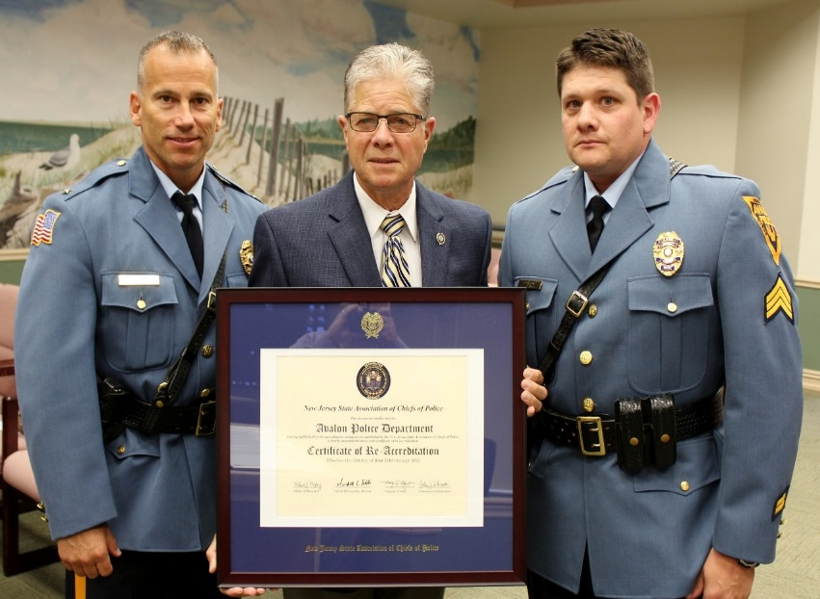
New employees in 2019

We began 2019 with the hiring of a full-time patrolman to replace a retiring officer. The hiring of an officer is an extensive process. Our process begins with a physical fitness assessment test. If an applicant passes, they move to the oral examination, interview and background check. Lukas Hill was selected for the position and was sworn in on January 18, 2019. (Pictured below)

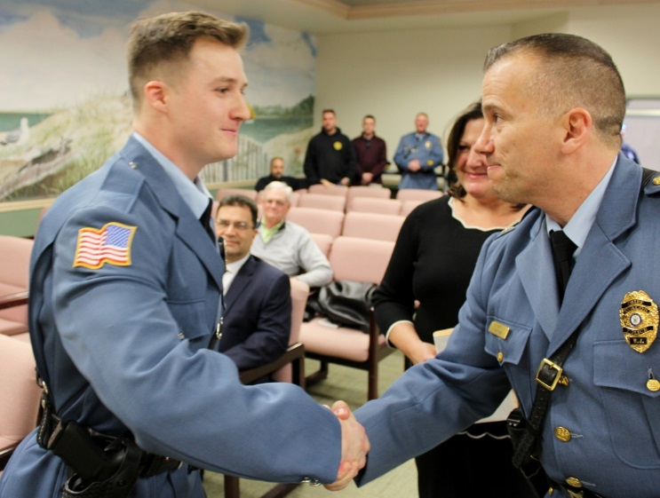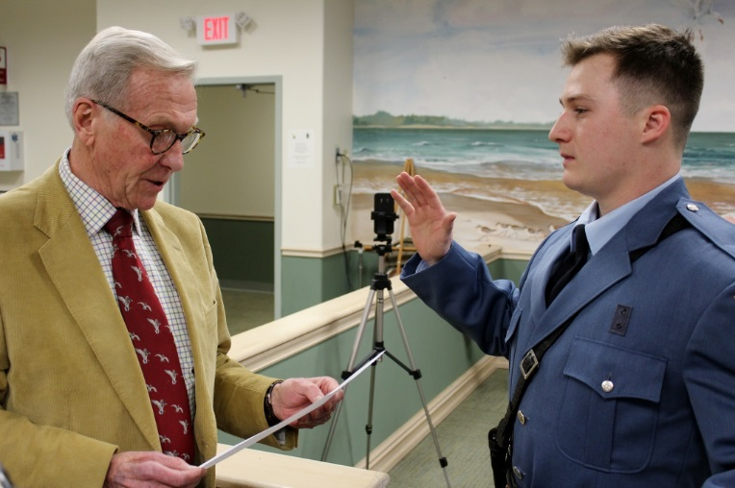

Alexis Hagner was selected to replace Noreen Fitzpatrick as the Administrative assistant. Nearly 20 qualified individuals interviewed for the position and Alexis was selected for her wide range of skills. She started on February 5, 2019. Alexis is also a special officer and dispatcher.

The APD had two resignations from within our Dispatch staff. Wendy Connell, who was with the Department for 12 years, retired to care for a family member. Melissa Cahill retired to seek another full-time position. Melissa remains as a part-time dispatcher. We hired Nicholas Seliger and Alyssa Jones.
Community activity

The Avalon Police Department takes pride and makes a strong effort to work with the community and participate in events.

AHLOA
On April 13, 2019 the A.P.D participated in the AHLOA community connections. A table was set up and important information was provided to community members.

In August 2019, Chief Christopher attended the AHLOA public safety meeting and presented an annual power-point presentation which can be found on the AHLOA website.

In October, Chief Christopher re-instituted monthly meetings with members of AHLOA. Wayne Popowski was designated as the Public Safety liaison. Chief Christopher meets with Mr. Popowski every month to discuss issues within the Community. We are proud to have an outstanding relationship with AHLOA.

Special Olympics

In June 2019, Sergeant Sean McNair, Ptlm. Charles Hewitt, Patrolman Matt Ardelean, and Patrolman Lukas Hill volunteered and traveled to the College of New Jersey in Trenton to assist with the Special Olympics games to hand out metals to the athletes. We are proud and honored to assist the Special Olympics in any way we can. (pictured below)

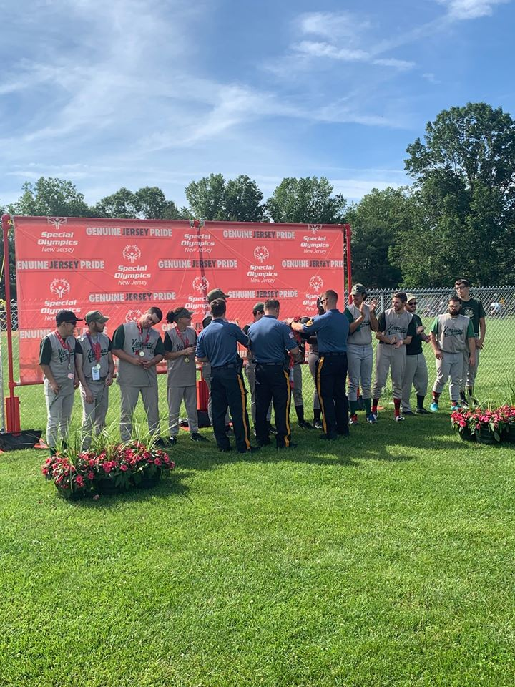

Also in June, five members of the Department participated in the Law Enforcement Special Olympics Torch run. The run raises awareness and funds for the Special Olympics games. The Torch run starts in Cape May, travels through the Wildwoods and Stone Harbor, finishing at the Police Academy in Crest Haven. Members of the APD ran six (6) miles. Pictured below are Chief Christopher, Sgt. Sykes, and Sgt. Robinson, Detective Greg Armstrong, and Alexis Hagner.
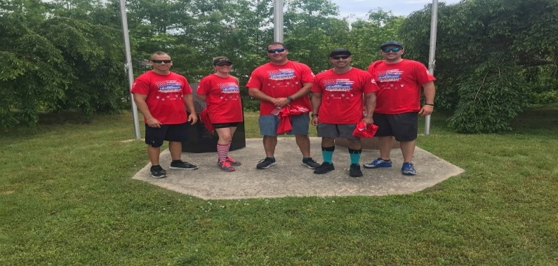

Cops n coffee

The Avalon Police Department continues to host “Cops N Coffee” events. The purpose is to engage with the community and allow members of the public to meet officers and have a friendly conversation in an casual setting. The public is encouraged to express any problems, issues, or suggestions they may have. This year we hosted it on May 11 at the Police Department. We had an “Open House”, for people to walk through and have tours of the building.

Bike Safety initiative
The APD decided to take another approach to increase bicycle safety, all while promoting local businesses, and improve community trust and relationships. The APD created the Bicycle safety initiative. Created by Sgt. Sean McNair, officers would look for bicyclists that were following all bike laws and safety practices. When these individuals were spotted, officers would conduct a voluntary encounter and provide them a bike safety initiative card which had coupons or discounts to many local Avalon businesses. Many thanks go to the Avalon Chamber of Commerce and Jacquie Ewing of the Armadillo for their help getting the program started.
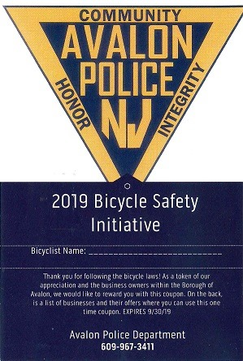
National Night Out

Members of the Avalon Police Department participate in National Night Out. This is a great opportunity to allow the public to get to know the officers. Kids enjoy getting a tour of the police vehicles. This year we also had a “dunk tank”. Chief Christopher, Captain Roscoe, and Detective Greg Armstrong all got dunked.

Captain Roscoe Ptlm. Ardelean and S/O Hagner

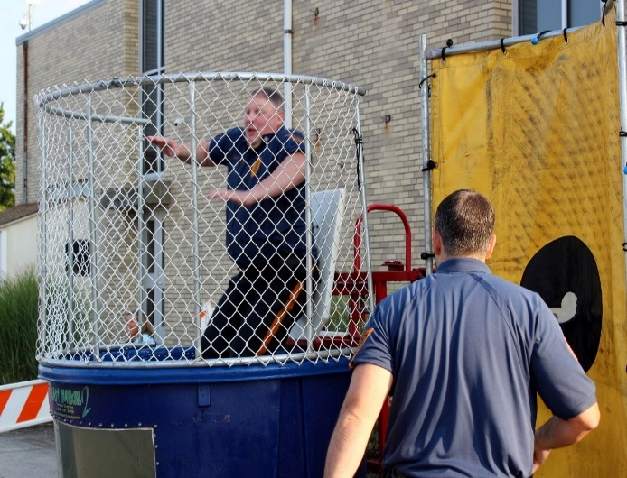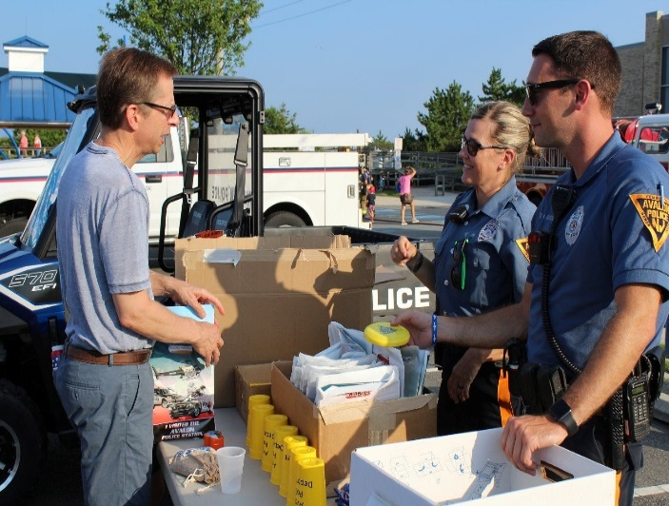

Trunk or Treat

On October 29, 2019, Detective Greg Armstrong dressed as a “zombie clown police officer”, for the annual Avalon Borough trunk or treat.
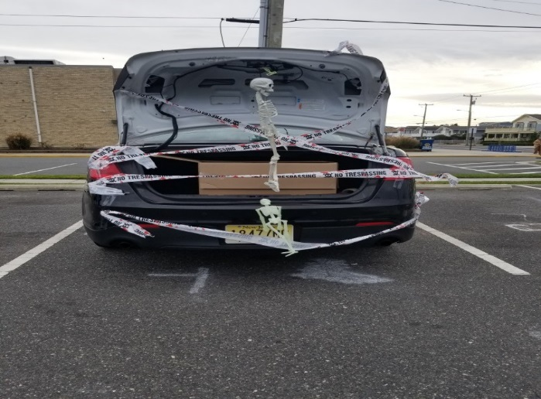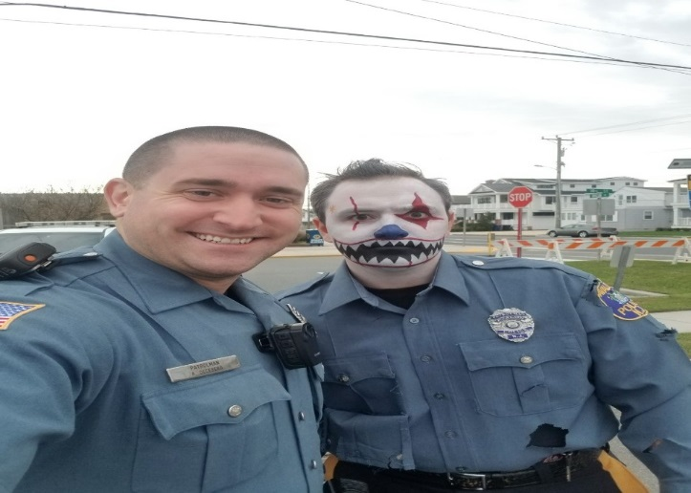

Festive Friday

In the parking lot of the Police Department we hosted a bounce house for kids. We cooked over 500 hotdogs and provided bottled water. We conducted and “open house” and gave tours of the police building. Approximately 200 people were given a tour of the building by Detective Greg Armstrong. Sgt. Sykes and Sgt. Heisman cooked the hotdogs.
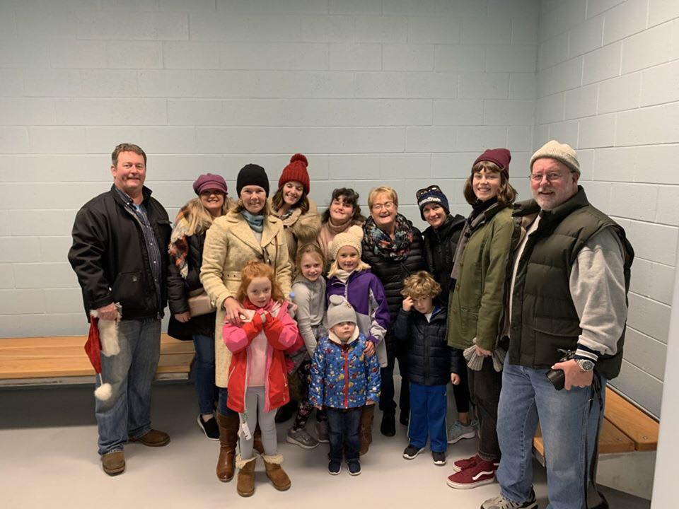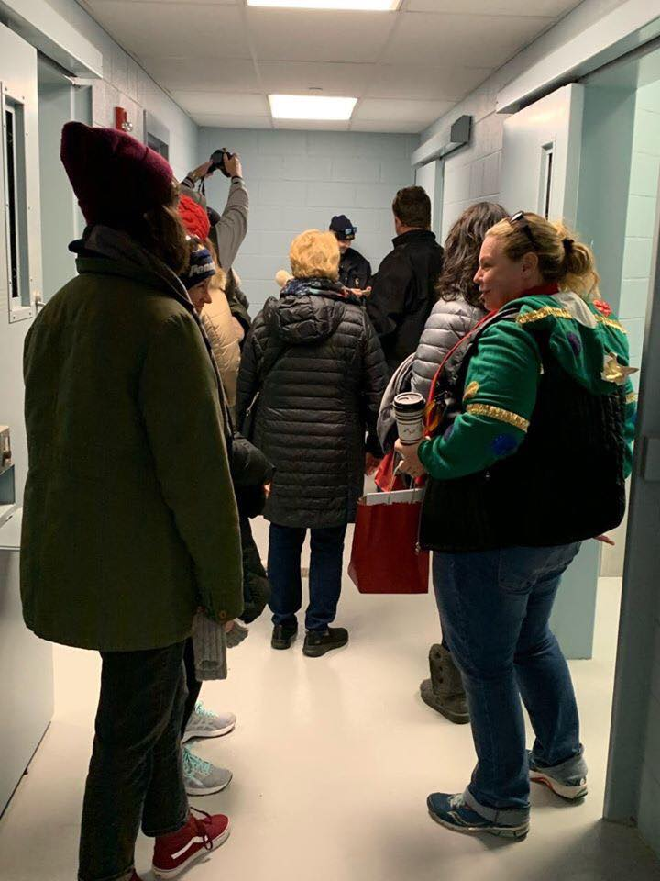

Christmas Toy Drive

The Avalon Police Department initiated a “toy drive” for children in need. Toys were donated by Avalon P. D. members, local businesses, and citizens. This event far exceeded our expectations. Headed by Sgt. Sean McNair, toys were given to the Local office of the Division of Child Protection and Permanency. (Formerly Division of youth and Family Services, DYFS). Our administrative staff, Dawn Brady, Debbie Foley, and Alexis Hagner wrapped all gifts. Six officers volunteered their own time to deliver the gifts. Pictured below, Sgt. Sean McNair, Sgt. Eric Heisman, Sgt. Steve Bowers, Ptlm. Matt Ardelean, Ptlm. Chris Nazha, and Ptlm. Lucas Hill. Also, captured in the second photo is Retired Sgt. Al Gombar, now providing security at the office.

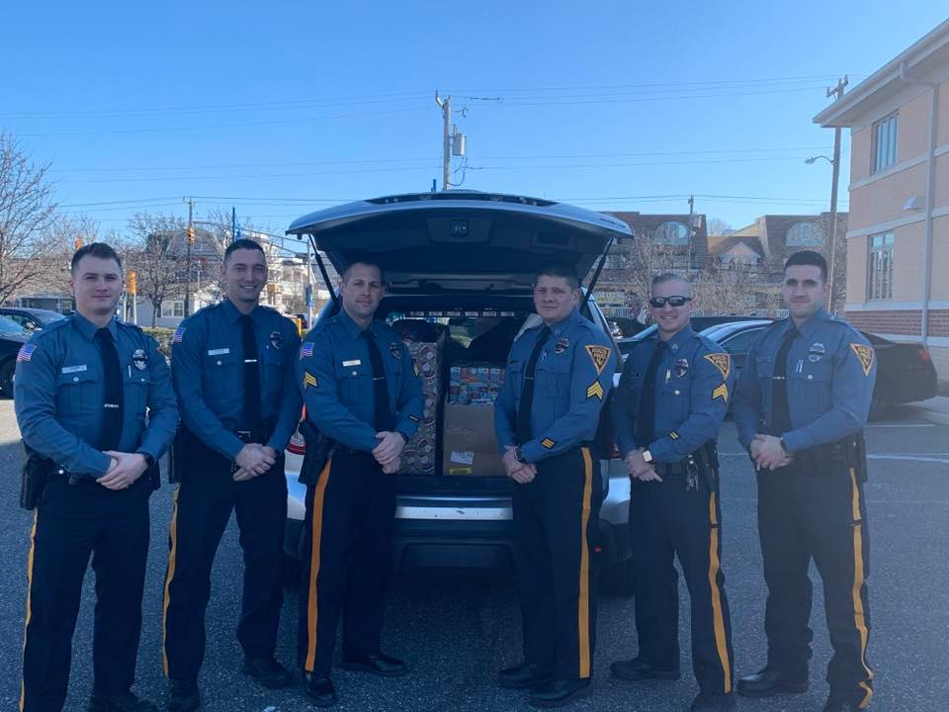

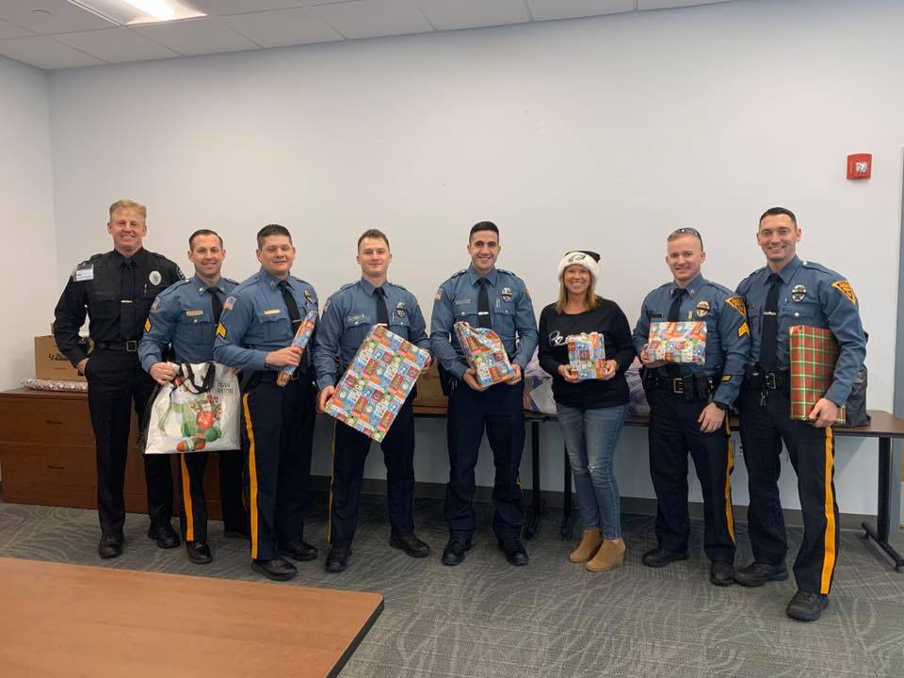

Police Unity Tour

The Police Unity Tour is a 3-day bike ride that originates in Atlantic City and travels to the National Law Enforcement memorial in Washington D.C. Over the years, the Avalon Police Department has had numerous officers participate in the local Chapter of the tour. The officers are required to raise approximately $2000 in donations to be permitted to ride and that money goes to maintaining the National Law Enforcement memorial in Washington D.C. In 2018, we had three (3) officers make the ride. Sergeant Sean McNair, Detective Sergeant Matthew Sykes and Patrolman TuJuan Baile traveled over two hundred miles, representing the Avalon Police Department and Officers who have fallen in the line of duty.

The Avalon Rescue squad also volunteered an ambulance to follow the tour. The ride made stops in Delaware, Annapolis, and the 3rd day was the arrival to the memorial. Throughout the ride, multiple stops were made in each state where an officer has been killed in the line of duty.

Equipment

Two significant pieces of equipment were purchased this year. The Live Scan fingerprinting device is the most up to date technology. It is able to acquire finger prints and palm prints.

A speed radar trailer. This unit is easily moved to different locations to respond to complaints and control speeding. It has technology that records all vehicles traveled in the area to display vehicle speeds. It is solar powered with a battery backup. The battery needs to be charged only once per month allowing for more time in each location. We positioned the device on 42nd street, and at the Townsends Inlet Bridge after receiving complaints of speeding. Additionally, the units were placed on Ocean Drive, Dune drive, and First Avenue to control speeding.

S.W.A.T

The Avalon Police Department added another officer to the Cape May County Special Weapons and Tactics Team part time. Officer Anthony DeCesero was selected by the Cape May County SWAT team. There are now two officers assigned to the team, Zach Saduk and Anthony DeCesero. Their primary responsibility is to patrol for the Borough of Avalon, however they are assigned to a special twelve (12) hour training once per month. DeCesero attended a basic SWAT operator course for five (5) days in Moyock North Carolina, (formerly Blackwater). They will respond to any SWAT operation county wide upon a “call out”. This year, the county team had 49 call outs, for such things as: Barricaded suspects, high risk narcotics search warrants, etc.
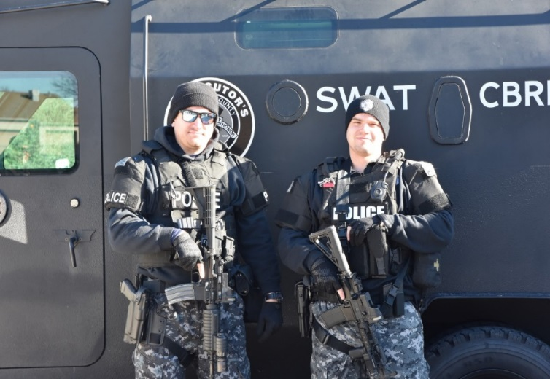

Recognition and awards

Members of the Avalon Police Department volunteer to form an awards committee. The committee will discuss events and cases throughout the year to determine if any awards should be given. Strict guidelines on the issuance of awards are adhered to in order to maintain the integrity of the system. The following awards were given at the annual 2019 dinner for the calendar year of 2018.

Life Saving Award
Sgt. Sean McNair
On March 28, 2018, Sgt. McNair responded to the 700 block of Sunrise Drive for a report of a potential overdose. He quickly arrived and found the patient blue in the face and unresponsive. Sgt. McNair administered one dose of Narcan. His professional actions assisted the patient in regaining consciousness.
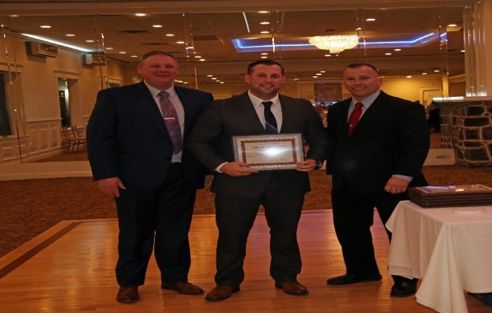

Exceptional Duty Award
Sgt. Matthew Sykes
On October 5, 2018 Detective Sgt. Sykes received a report of a sexual assault. With little notice, he put his personal life on hold to conduct the investigation. He immediately went to North Carolina to interview the victim, family and friends. His investigation then took him to Lancaster PA, and finally to New York City to interview the suspect. His thorough investigation allowed him to establish enough probable cause to charge the suspect and obtain an indictment.
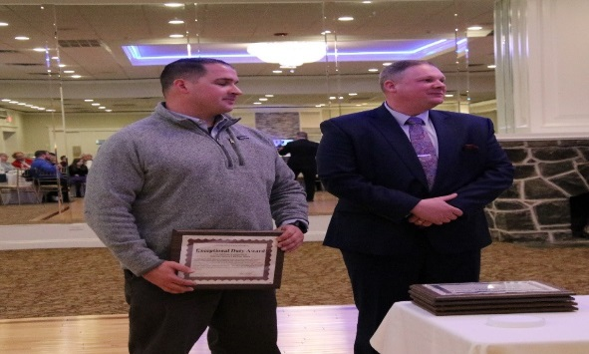

Nicholas Brady Dedication to Duty Award
Ptlm. Nicholas Brady is recognized for his sincere dedication to the Department and his fellow employees, by his faithful attendance to duty on each and every day scheduled to work in 2018 by not using any sick time.

Matthew Ardelean Dedication to Duty Award
Ptlm. Matthew Ardelean is recognized for his sincere dedication to the Department and his fellow employees, by his faithful attendance to duty on each and every day scheduled to work in 2018 by not using any sick time.

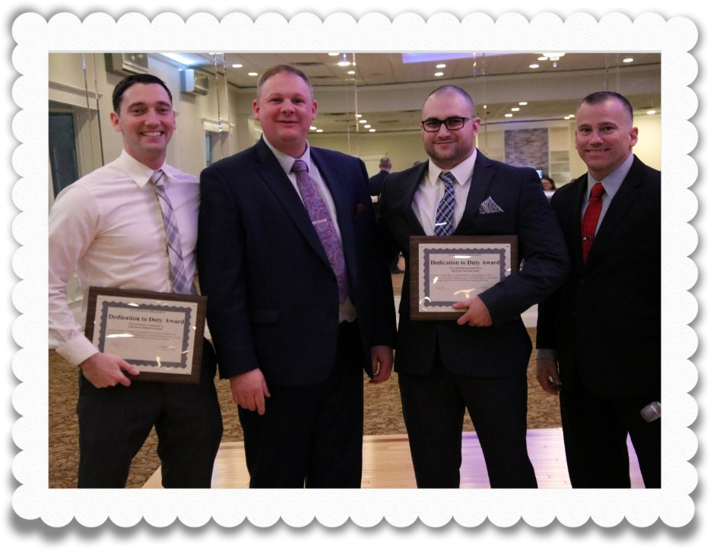

Bicycle Enforcement

In recent years, bicycle safety has been a top priority. For many years there has been an increased number of bicycles on the roadway. Many of these bicyclist were violating the laws of the road as well as putting themselves or others in a dangerous situation. We made significant changes to the way we deploy officers and their assignments to combat this problem. The primary strategy used is to educate bicyclists on the laws and dangers of operating bikes in an unsafe manner. Safety of the citizens is the driving force behind this initiative. In 2018 there were 1998 stops conducted on bicyclists which was slightly lower than 2017. I believe that is due to the increased efforts and citizens becoming educated in addition to the added bike paths therefore creating slightly fewer violations. Each of these stops resulted in, at minimum, the operator being explained the laws and dangers of unsafe riding, and provided a safety card with important information. These stops also increase officer / citizen contacts which strengthen our community relationships.

New Department Logo

The APD began displaying a new department logo. This logo was designed by Captain John Roscoe. It represents the three things most important to the APD.

COMMUNITY
HONOR
INTEGRITY
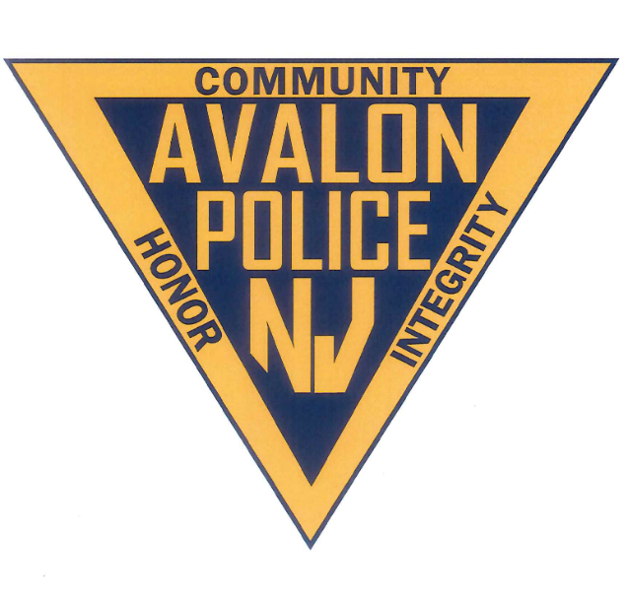

SUMMARY

As you have seen in this report, the Avalon Police Department has had an active year. Since I became the Chief of Police, my main goal was to continue to move the police department in a positive direction to accomplish public safety and outstanding community relationships. 2019 started out with myself attending the Command and Leadership academy. Continual training on leadership principles for supervisory and command staff is as important as training patrol and investigative techniques to the officers and detectives on the front lines. My plan is to have all supervisor staff attend the command and leadership academy. At the time of this report, Captain John Roscoe has already began and is attending the course.

Community activity has always been a priority of mine. We are engaging with the community much more than we have in the past by participating in more events and regularly communicating through social media. We made attempts to post something on Facebook often to keep the public informed and involved. We are attempting to make a difference in the lives of the people we serve by participating in events to raise money and awareness to the Special Olympics. Sponsoring “toy drives” to help bring joy to children that may otherwise have not had a Christmas. Engaging with our youth often with events such as National Night Out and Trunk or Treat, and rewarding kids for following all bicycle laws in an attempt to change the perception of Police Officers. Inviting the public to tour our building and vehicles to build trust and relationships. Utilizing body worn cameras, to better train and maintain transparency.
Traffic safety continues to be on the forefront of our mission. As this report will demonstrate, motor vehicle and bicycle violations are a major focus of our patrols and are rationally enforced. Officers made an astounding 3211 motor vehicle stops with 16% resulting in a summons for the more egregious violations. The number of bicycle stops conducted was 1838 but the number of people contacted was far higher with many of these stops having more than one bicyclist.

We utilize speed radar trailers to monitor and deter speeders. Most complaints for speeders are answered by placing a radar trailer at that location to determine the severity and patterns of speeding.

This year we acquired much needed equipment such as: “LiveScan”, the most up to date fingerprinting system, and “Star Witness”, an advanced video recording device for conducting suspect interviews. We have also made addition to our firearms program. Obtaining the proper equipment is essential for performing our jobs properly and maintaining a high level of employee morale’.

Sexual assaults were the most serious crime recorded but it remains a rarity. Thanks to diligent investigations, Sgt. Matt Sykes was able to solve a case and bring closure to the victim and charge the suspect with various crimes.

Avalon officers have seen firsthand the effects of the Opioid epidemic. Officers carry Narcan and have had to deploy it several times over the past few years. Sgt. Sean McNair was awarded in 2019 for his life saving efforts.

GOALS AND OBJECTIVES
A continual challenge for this Department is hiring and maintaining qualified applicants for our Special officer Positions. For this reason, we have stepped up our efforts in recruiting. We now seek out and attend various local Job fairs. We attended seven job (7) fairs this year including, Cape May Technical school, Rowan University, Rowan at Gloucester County, Rowan at Burlington County, Monmouth University, Stockton University, and West Chester University.

With the deterioration of our current borough video surveillance system, we have begun planning and building a new town watch security system. We hope to have this system acquired this year. We want to have all avenues of ingress/egress, as well as various other locations throughout the borough monitored by state of the art surveillance system.

To keep up with the changing times, we plan to make improvements to our social media information to include: Instagram and Twitter.

CONCLUSION

Thank you for taking the time to review the Avalon Police Department 2019 annual report. I would like to thank Mayor Pagliughi, Borough Council members, Borough Administrator’s Scott Wahl and Jim Waldron and members of AHLOA for your continued support. It is an honor and a privilege to serve this great community.
Respectfully Submitted,
Jeffrey R. Christopher
Chief of Police

