AVALON POLICE DEPARTMENT |  |  |  |  |  |  |  | 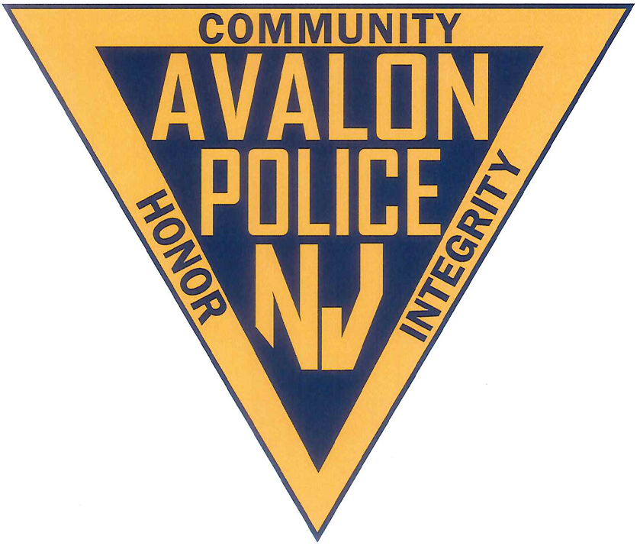
Standard Operating Procedure #:  19 | EFFECTIVE DATE:  11/20/00 |  |  | NUMBER OF PAGES:  4
SUBJECT: Drug Testing Programs

BY THE ORDER OF:  Chief Jeffrey Christopher |  | SUPERSEDES ORDER: |  |  |  | REVISION DATE |  |  | PAGE #
2/28/2008
4/27/2015 1,2
01/04/2018 ALL

ACCREDITATION STANDARDS

I. PURPOSE

To establish procedures for conducting drug testing for newly hired and returning seasonal sworn personnel, as well as to establish procedures for the random drug testing procedure to comply with the Cape May County Association of Chiefs of Police, S.O.P. No. 11, and the Attorney General’s Law Enforcement Drug Testing Policy.

II. POLICY

The Chief of Police shall conduct a random drug testing program in accordance with
guidelines established by the New Jersey Attorney General; procedures established by the
Cape May County Prosecutor through the Cape May County Police Chief’s Policy Manual SOP #11 and Procedures established by the Chief of Police.

III. PROCEDURE

It shall be the policy of this department that applicants to the police hiring process will be required to submit a urine sample at any point in the pre-employment process. Additionally, applicants for employment may be tested as many times as the Chief of Police deems necessary to ensure that the applicant is not engaged in the illegal use of drugs. The medication information form will not be used at the applicant stage, unless a positive test result requires an explanation by the prospective employee.

Applicants will be advised in writing that they will be required to submit a urine sample for drug use analysis.
- Applicants will be advised that a negative result is a condition of employment and that a positive result will:
  - Result in the applicant being dropped from consideration for employment
  - Cause the applicant’s name to be reported to the central drug registry maintained by the NJ State Police, and
  - Preclude the applicant from being considered for future law enforcement employment in New Jersey for a period of two years.
- If the applicant is currently a law enforcement officer with another agency and tests positive, the officer’s agency will be notified.
It shall be the policy of this department that drug tests will be conducted of all law enforcement trainees while attending a mandatory basic training course. The drug testing of law enforcement trainees will be conducted by the academy staff under rules and regulations adopted by the Police Training Commission. Individual trainees will also be required to submit a urine sample for testing when there exists reasonable suspicion to believe the trainee is illegally using drugs.

- All trainees will be informed that drug testing is mandatory during basic training. Trainees will also be informed that a negative result is a condition of employment and that a positive result will cause:
- The officer’s termination from employment; and
- Inclusion of the officer’s name in the central drug registry maintained by the Division of the State Police; and
- The officer being permanently barred from future law enforcement in New Jersey
- Trainees will be further informed that the refusal to submit to drug test will result in their dismissal from employment and a permanent ban from future law enforcement employment in New Jersey.

It shall be the policy of this department that all sworn law enforcement officers can be ordered to submit a urine specimen for drug testing under the following circumstances:

  - Urine specimens will be ordered, with the prior review of the County Prosecutor or his designee and the Chief of Police, when there exists reasonable suspicion to believe that the officer is illegally using drugs.
  - Urine Specimens will be ordered from officers that have been randomly selected.
  - Urine specimens will be collected during a regularly scheduled and announced medical examination for fitness of duty examination.

A. All law enforcement officers of the Avalon Police Department are eligible for random
drug testing, regardless of rank or assignment.

B. The Chief of Police, or his designee, shall order individual officers to submit to a
drug test when randomly selected for drug testing.

- The random selection for basic drug testing will occur twice annually, at a minimum. The Chief of Police will cause a minimum of 10 % of the law enforcement officers in department to be randomly selected after certifying the list of eligible officers. The random selection will occur before each of the bi-annual testing and will always be a minimum of 10 % of the law enforcement officers.

- When a sworn law enforcement officer tests positive for illegal drug use:

  - The officer will be immediately suspended from all duties without pay;
  - The officer will be terminated from employment as a law enforcement officer, upon final disciplinary action;
  - The officer will be reported to the Central Drug Registry maintained by the Division of State Police by the Chief of Police;
  - The officer will be permanently barred from future law enforcement employment in New Jersey.
  - A sworn officer who tests positive for illegal drug use or refuses to submit to a drug test, and who resigns or retires in lieu of disciplinary actions prior to the completion of final disciplinary action, will be reported by the Chief of Police to the Central Drug Registry and will be permanently barred from future law enforcement employment in New Jersey.

E. The Chief of Police shall direct the detective bureau to collect urine samples consistent with the New Jersey Attorney General’s Guidelines on Law Enforcement Drug Testing Policy for all returning seasonal sworn employees as part of the re-hiring process.
Those returnees failing the drug test or those who fail to submit to drug testing will not be considered for reemployment. The following will be noted in the returnee’s
personnel file:

- Copies of the notice to participate in drug testing
- Whether or not the returnee submitted to the drug testing

Officers are advised that a negative result is a condition of employment and that a positive result will result in:
a) termination from employment; and
b) inclusion of officers name in the central drug registry maintained by the Division of State Police; and
c) officer will be permanently barred from future law enforcement employment in New Jersey.

Refusal to submit to the urinalysis drug test shall result in the officers dismissal from employment and a permanent ban from future law enforcement employment in New Jersey.

REASONABLE SUSPICION TESTING

It shall be the policy of this department that individual law enforcement officers will be ordered to submit to a drug test when there is a reasonable suspicion to believe that the officer is illegally using drugs. Reasonable suspicion requires objective facts which, with inference, would lead a reasonable person to conclude that drug-related activity is taking or has taken place and that a particular individual is involved in that drug activity.

The following factors will be evaluated to determine the quality and relevance of the information acquired by the police department:

  - The nature and source of the information
  - Whether the information constitutes direct evidence or is hearsay in nature
  - The reliability of the informant or source
  - Whether corroborating information exists and the degree to which it corroborates the accusation, and
  - Whether and to what extent the information may be stale.

The Chief of Police, or his designee will prepare a written report which documents the basis for the reasonable suspicion. The report will be reviewed by the County Prosecutor.

A negative result from any drug testing is a condition of employment as a sworn officer. A positive result will cause:

- The officer’s termination from employment; and
- Inclusion of the officer’s name in the central drug registry maintained by the Division of the State Police; and
- The officer being permanently barred from future law enforcement in New Jersey
- Refusal to submit to the urinalysis drug test shall result in the officer’s dismissal from employment and a permanent ban from future law enforcement employment in New Jersey

